Agenda Item: 1/03

= application site

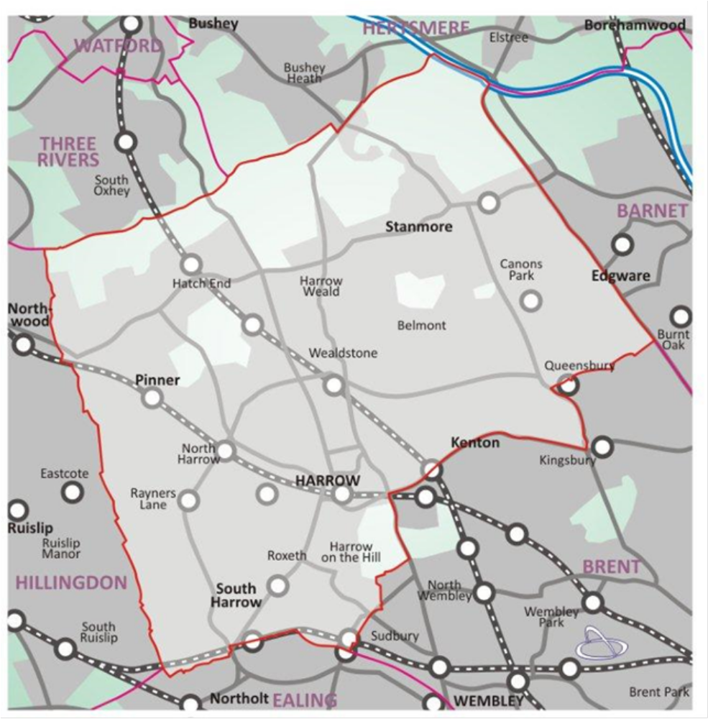

33-39 LOWLANDS ROAD, HARROW, HA1 3AN | P/1656/20

33-39 LOWLANDS ROAD, HARROW, HA1 3AN

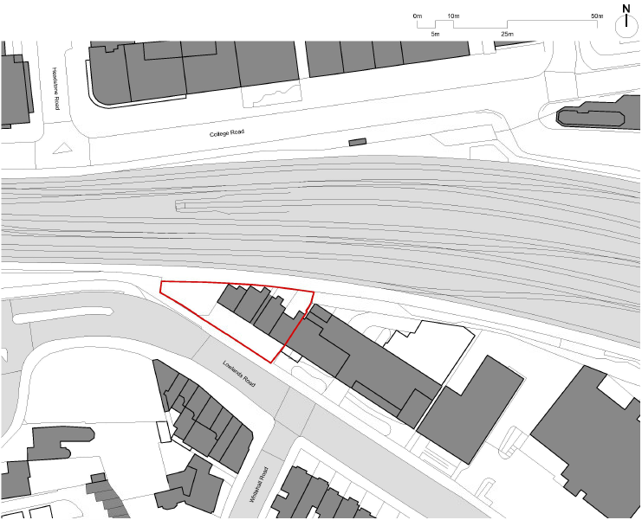

LONDON BOROUGH OF HARROW

PLANNING COMMITTEE

23rd September 2020

APPLICATION NUMBER: | P/1656/20
VALID DATE: | 01/06/2020
LOCATION: | 33-39 LOWLANDS ROAD, HARROW
WARD: | GREENHILL
POSTCODE: | HA1 3AN
APPLICANT: | DEFINITION CAPITAL
AGENT: | Q SQUARE
CASE OFFICER: | KATIE PARKINS
EXPIRY DATE: | 31st OCTOBER 2020

PROPOSAL

Redevelopment to provide 9 storey building with basement level comprising of 104 co-living units (Use class Sui Generis) with communal living area; co-working space and cafe (Use Class E) to ground floor level; proposed vehicle access; hard and soft landscaping; bin and cycle stores; parking

RECOMMENDATION

The Planning Committee is asked to:

RECOMMENDATION A
1) Agree the reasons for approval as set out in this report, and

2) Grant planning permission subject to authority being delegated to the Interim Chief Planning Officer in consultation with the Director of Legal and Governance Services for the completion of the Section 106 legal agreement and other enabling legislation and issue of the planning permission and subject to minor amendments to the conditions (set out in Appendix 1 of this report) or the legal agreement. The Section 106 Agreement Heads of Terms would cover the following matters:
1. Tenure and Management
- Tenure and Management Strategy
2. Affordable Housing Contribution and Viability Review
- Early Stage Review
- Commuted sum – £200,000
- To pay the affordable housing contribution prior to the commencement of development.
3. Highways
- Development to be Resident Permit Restricted: With the exception of disabled persons, no resident of the development shall obtain a residents’ parking permit within the Controlled Parking Zone. An additional £1,500 contribution towards the cost of amending the traffic order.

- S278 - new/altered access to the highway

- Short stay cycle parking – supply and installation cost - £2,000

4. Travel Plans
- Travel Plan Bond (to be agreed with developer) will be required to secure the implementation of all measures specified in the Travel Plans.

- Travel Plan monitoring Fee - £5000 to cover a 5 year period, per Travel Plan.

- Travel plan survey – Surveys are to be conducted in year 1, 3 and 5 and interim progress reports in year 2 and 4 will be requested by agreement.

- Submit survey results annually with full review and update in years 3 and 5

- Travel Plan Co-ordinator to be in place 2 months prior to occupation.

- Monitoring of the plan is to take place following a baseline survey. Targets should be re-evaluated and agreed with Council Officers. Baseline survey scheduled to be detailed by agreement.

5. Employment and Training – Construction Employment
- The developer to submit to the Council for approval, prior to commencement of the development, a Training and Recruitment Plan/ Local Labour Employment Strategy. The developer to implement the agreed Plan. The training and Employment plan will include:
- employment initiatives opportunities relating to the construction of the Development and details of sector delivery;
- the provision of appropriate training with the objectives of ensuring effective transition into work and sustainable job outcomes;
- the timings and arrangements for implementation of such initiatives and
- suitable mechanisms for the monitoring of the effectiveness of such initiatives

- The developer to use all reasonable endeavours to secure the use of local suppliers and apprentices during the construction of the development.

- A financial contribution towards the management and delivery of the construction training programme based on the construction value of the development. This is calculated using the formula: £2,500 per £1,000,000 build cost.

6. Carbon Offset
- £52,740 carbon offset payment prior to the commencement of development (circa 27 tonnes offset per annum)

- Submission of final ‘As-Built’ Part L calculations confirming the carbon reductions achieved on-site and those to be offset through monetary contributions to achieve zero carbon development for the residential element and a 35% reduction for the non-residential element. If additional carbon emissions need to be offset above that already paid (i.e. £48,540 or 27 tonnes per annum), an additional contribution will be calculated on the basis of £60 per additional tonne per year to be offset x 30 years i.e. £1800 per tonne) and payable within 1 month of notification of this amount by the LPA.

7. Legal Costs, Administration and Monitoring

- A financial contribution (to be agreed) to be paid by the developer to the Council to reimburse the Council’s legal costs associated with the preparation of the planning obligation.

RECOMMENDATION B

That if the Section 106 Agreement is not completed by 21st December 2020, or as such extended period as may be agreed by the Interim Chief Planning Officer in consultation with the Chair of the Planning Committee, then it is recommended to delegate the decision to REFUSE planning permission to the Interim Chief Planning Officer on the grounds that:

The proposed development, in the absence of a Legal Agreement to provide appropriate improvements, benefits and monitoring that directly relate to the development, would fail to adequately mitigate the impact of the development on the wider area and provide for necessary social, environmental and physical infrastructural improvements arising directly from the development, contrary to the National Planning Policy Framework (2019), policies 3.11, 3.13, 5.6, 5.12, 6.3, 7.4, 7.5, 7.6 and 7.7 of The London Plan (2016), Core Strategy (2012) policy CS1, policies DM 1, DM 2, DM 9, DM 13, DM 42, DM 43 and DM 50 of the Harrow Development Management, Polices Local Plan, policies AAP1, AAP4, AA6, AAP8, AAP13, AAP19 and AAP20 of the Harrow and Wealdstone Area Action Plan (2013) and the Supplementary Planning Document: Planning Obligations (2013).

REASON FOR THE RECOMMENDATION

The proposed development would bring forward housing provision of a satisfactory layout and design to ensure that the future occupiers would benefit from a high standard of living accommodation. It is considered that the proposed building would have an acceptable design and external appearance and would not have an undue impact on the character and appearance of the area or the residential amenity of neighbouring occupiers. Accordingly, the development would accord with development plan policies and is recommended for approval.

INFORMATION

This application is reported to Planning Committee as it would provide in excess of 3 new residential units. The application is therefore referred to the Planning Committee as it does not fall within any of the provisions set out at paragraphs 1(a) – 1(h) of the Scheme of Delegation dated 12th December 2018.

Statutory Return Type: | All other Largescale Major Development
Council Interest: | None
Net Floorspace: | 3,609 sqm
GLA Community Infrastructure Levy (CIL) Contribution (provisional): | £216,540
Local CIL requirement: | N.A

HUMAN RIGHTS ACT

The provisions of the Human Rights Act 1998 have been taken into account in the processing of the application and the preparation of this report.

EQUALITIES

In determining this planning application the Council has regard to its equalities obligations including its obligations under section 149 of the Equality Act 2010.

For the purposes of this application there are no adverse equalities issues.

S17 CRIME & DISORDER ACT

Policies 7.3.B and 7.13.B of The London Plan and Policy DM1 of the Development Management Polices Local Plan require all new developments to have regard to safety and the measures to reduce crime in the design of development proposal. It is considered that the development does not adversely affect crime risk. However, a condition has been recommended for evidence of certification of Secure by Design Accreditation for the development to be submitted to and approved in writing by the Local Planning Authority before any part of the development is occupied or used.

- SITE DESCRIPTION

  - The site occupies a triangular-shaped plot and has a prominent location when approaching the town centre from the south and Lowlands Road from the west. The site is also visible from College Road to the north, with the railway intervening.

  - The north side of Lowlands Road has an eclectic range of architectural styles, largely postmodern and of limited architectural quality, centred around office typologies.

  - The application site is within the setting of the Roxborough Park and the Grove Conservation Area and the locally listed group of buildings opposite 26 to 40 Lowlands Road. In addition, the site is located within a landmark viewing corridor from Old Redding viewpoint and within the wider setting consultation area of other protected views.

- PROPOSAL

  - The proposal is for the redevelopment of the existing site and the construction of a 9 storey building with basement to provide 104 co-living units (use class – sui generis) with communal living area. A co-living working space is proposed at ground floor level.

  - Three accessible parking spaces are proposed along with an internal cycle store and cycle store to the rear.

  - Refuse and recycling would be stored internally at ground floor level with a bin collection area to the front.

- RELEVANT PLANNING HISTORY

  - N/A

- CONSULTATION

  - A total of 463 consultation letters were sent to neighbouring properties regarding this application.

  - A site notice was posted on 16th March 2020 and a Harrow Times advert was published on the 4th June 2020.

  - The overall public consultation period expired on the 29th June 2020. 3 objections were received and are summarised below.

Character and appearance:
- 9 stories tall, an enormous box of little or no architectural merit.
- Attempts to get as much on a small space as possible.
- It abuts the conservation area and is opposite locally listed buildings, how does it enhance the area.
- Given this application and the others in the adjoining buildings, the number of units must be approaching 500.

Officer response: Given the varied character of the locality and the appropriate scale and design of the proposal it is considered that the proposal would not detract from the character and appearance of the area.

Highways:
- Insufficient parking, how can they enter and exit safely given the speed of traffic off the roundabout.
- How will rubbish be collected.
- Should be parking permit restricted.

Officer response: The Council’s Highways Officer has confirmed that given the as the existing site is not permit restricted and given that car ownership is fairly low with lower occupancy units, it is not considered that the development would cause on-street parking stress.

Housing Type/Quality
- Co-living space is unsuitable in pandemic.
- Unhealthy crowded living.
- Encouraging transient living not conducive to the community.
- Rooms small in size.
- Communal space limited
- Anti-social issues.

Officer response: Co-living housing is supported by The Draft London Plan (2019).

  - 2 letters of support were received and are summarised below.

Character and appearance:
- Redeveloping it with a new building of good quality design will enhance the appearance of the area and create new housing near the station for people who cannot afford to purchase their own home in the town centre.
- I like the design, fantastic compared to what is there now and the co-working space and café is nice for the local community to use.
- The existing building is ugly and not fit for purpose.
- Doesn’t fit in with the streetscene.
- The architecture is particularly attractive compared to what is there now.
- Will look good from the town centre.

Officer response: Noted.

Housing Type/Quality
- Co-living sounds like a great new concept where you have your own self-contained space but the opportunity to socialise with others.
- Great way to address the housing shortage.

Officer response: Noted.

  - Statutory and Non Statutory Consultation

  - A summary of the consultation responses received along with the Officer comments are set out in the Table below.

Consultation Responses

LBH Highways
This proposal is within a PTAL 6A location meaning that access to public transport is considered to be excellent. The site is a short walk from Harrow on the Hill Underground Station which also gives access to Harrow Bus Station and the town centre shopping area. For those who do occasionally need to travel by car, residents will be able to access existing car club vehicles which are located in the surrounding area (Roxborough Road, College Road and Gayton Road). The proposed level of disabled parking provision is acceptable. The proposed level of cycle parking and storage is acceptable. An appropriate condition should be applied requiring details to be submitted for approval prior to occupation and should secure the implementation of the cycle storage and its permanent retention. The trip generation method is generally acceptable.

Access and Servicing
The proposal to close the existing accesses and provide a new access towards the north of site would mean that it is on a bend however, it is accepted that this position allows for good visibility in both directions. The proposed servicing arrangements have been determined based on the site being fairly constrained. Whilst on-street servicing is possible, a solution has been identified that would allow for some smaller vehicles to be able to use the under-croft facility.

Outline Construction Logistics Plan
A detailed CLP must be secured by pre-commencement condition and must follow TfL guidance. Application to discharge the condition should only take place when the main contractor has been selected to ensure that they are in agreement with the contents of the document.

Delivery and Servicing Plan and Car Park Design and Management Plan
The details are acceptable however, the intention to provide a formal shared use bay presents issues. Whilst it is possible that residents would be out during the day time, a 12 hour period is perhaps a little too long to expect anyone to be out on a daily basis. The two needs conflict therefore it needs to be established what the primary use of the parking area is intended to be. Realistically, deliveries are most likely to be undertaken from the roadside at this location unless drivers are already aware that they can access the under-croft; the reception staff/concierge would need to be anticipating deliveries and would need to know whether the parking area is fully occupied or not in order to manage activity effectively. Although it would be preferable to have all deliveries off-street, the proposed arrangement may be confusing and could cause problems for disabled drivers. Due to the expected number of daily deliveries, it should be possible to manage the use of the car park area without the need for a dedicated loading bay, however, it may be more acceptable to have general deliveries attend on-street but trades (eg. service engineer) or planned longer duration deliveries could be managed within the car park area by prior agreement and only if the demand for disabled parking allows for it.

Further information is required as set out above however, should this proposal be recommended for approval, conditions, a legal agreement for parking permit restriction and a section 278 highways agreement may be required.

Following the submission of an amended Transport Assessment the Highways Officer confirmed that the submitted details are acceptable.

Travel Plan
Use ONS or TRICS data to assess existing data from the locality or similar development else where. This will be reviewed following the baseline survey. Please update this within the travel plan. Travel Plan Co-ordinator should be appointed prior to occupation and details of this person to be provided to London Borough of Harrow. Please provide information of how/where residents and visitors can obtain cycle training. This should be in the welcome packs, on notice boards and website. Travel Plan monitoring fees to be secured by agreement. Amount to be detailed by agreement. In the event the Travel Plan is unable to meet targets, a remedial sum will be used to cover the cost of additional measures to support the achievement of targets. Remedial sum to be secured by agreement. Monitoring of the plan is to take place following a baseline survey. Targets should be re-evaluated and agreed with Council Officers. Baseline survey scheduled to be detailed by agreement. Surveys are to be conducted in year 1, 3 and 5 and interim progress reports in year 2 and 4 will be requested by agreement.

LBH Drainage
The drainage strategy and Flood Risk Assessment submitted by the applicant is satisfactory, however some details are still required and can be conditioned.

LBH Vehicle Crossing Officer
No objections to this proposal as there is already a dropped kerb in existence.

LBH Environmental Health
There are concerns about the development but the following conditions should ameliorate the matters:

- The development shall not begin until a scheme for the control of noise transmission to the adjoining dwellings has been submitted to and approved in writing by the Local Planning Authority. The scheme shall include such combination of sound insulation and other measures as may be approved by the LPA. Thereafter, the scheme shall be implemented and maintained in full compliance with the approved measures.

- No floodlighting or other form of external lighting shall be installed unless it is in accordance with details which have previously been submitted to and approved in writing by the Local Planning Authority. Such details shall include location, height, type and direction of light sources and intensity of illumination. Any lighting that is so installed shall not thereafter be altered without the prior consent in writing of the Local Planning Authority other than for routine maintenance which does not change its details.

- The development hereby permitted shall not commence until a scheme to deal with contamination has been submitted in accordance with the Supplementary Planning Guidance Document on Land Contamination and approved by the Local Planning Authority (LPA). The scheme shall include all of the following measures unless the LPA dispenses with any such requirement specifically and in writing:
  - A desk-top study carried out by a competent person to characterise the site and provide information on the history of the site/surrounding area and to identify and evaluate all potential sources of contamination and impacts on land and water and all other identified receptors relevant to the site;
  - A site investigation, including where relevant soil, soil gas, surface and groundwater sampling, together with the results of analysis and risk assessment shall be carried out by a suitably qualified and accredited consultant/contractor. The report should also clearly identify all risks, limitations and recommendations for remedial measures to make the site suitable for the proposed use; and
  - A written method statement providing details of the remediation scheme and how the completion of the remedial works will be verified shall be agreed in writing with the LPA prior to commencement, along with details of a watching brief to address undiscovered contamination.

(i) If during development works contamination not addressed in the submitted remediation scheme is identified, the updated watching brief shall be submitted and an addendum to the remediation scheme shall be agreed with the LPA prior to implementation; and

(ii) All works which form part of the remediation scheme shall be completed and a comprehensive verification report shall be submitted to the Council’s Environmental Protection Unit before any part of the development is occupied or brought into use unless the LPA dispenses with any such requirement specifically and in writing.

- There shall be no delivery and the loading or unloading of goods outside the hours of 0800 and 2000, Monday to Friday, and between the hours of 0900 and 1300 on Saturdays. There shall be no deliveries on Sundays or Bank Holidays.

- No air extraction system shall be used on the premises until a scheme for the control of noise and odour emanating from the site has been submitted to and approved in writing by the Local Planning Authority. The scheme shall include such combination of measures as may be approved by the LPA. Thereafter, the scheme shall be implemented and maintained in full compliance with the approved measures.

LBH Waste Management Policy Officer
No response received.

LBH Planning Policy Officer
No objection to the principle of development. The proposed methodology for the calculation of the affordable housing contribution is acceptable and as per what was previously

LBH Conservation Officer
This proposal is within the setting of the Roxborough Park and the Grove Conservation Area and the locally listed group of buildings opposite 26 to 40 Lowlands Road (attached). Lowlands Road is at the edge of the conservation area. There is a clear division between the relatively low density and historic development covering Harrow on the Hill on the conservation area side of Lowlands Road and the higher density, more modern and commercial development in the centre of Harrow.

The difference in height that is proposed would still be in keeping with levels along that side of the street (when taking account of the recent approval of permission next door and wider permissions approved in that area) and they would not harm the setting of the conservation area or any key views. The more urban character of the northern side of Lowlands Road would be maintained by the proposed design. There would be a connection to the character of Roxborough Park and the Grove Conservation Area given the design would pick up on the locally listed terrace.

Views looking towards the hill with this new building in the foreground are important and the one provided from Harrow Recreation Ground shows it would be below the treeline so it would preserve the setting of the Harrow on the Hill conservation areas.

CAAC
This constitutes over-development of a tight site with poor vehicle access onto Lowlands Road. The building is too high and will have an overbearing impact upon the opposite residential conservation area. There is little or no amenity area which will increase the pressure upon the adjacent green open spaces of the Grove and Lowlands conservation areas. This is much too large – should not exceed its neighbour, Roxborough Heights, in height.

LBH Urban Design Officer
Commercial properties along the northside of Lowlands Road are of reduced massing to the proposed but still represent a street frontage of significant height. As such the proposed development must be considered within its immediate context and in this regard there is justification for a building of height which has regard for its setting and the neighbouring conservation area. Commercial properties along the northside of Lowlands Road are of reduced massing to the proposed but still represent a street frontage of significant height. As such the proposed development must be considered within its immediate context and in this regard there is justification for a building of height which has regard for its setting and the neighbouring conservation area.

LBH Tree Officer
No objection.

LBH Biodiversity Officer
Whereas there are some general suggestions within the PEA as to potential mitigation/enhancement there is no assessment of existing value against which to assess losses and gains. Without a clear commitment to specific details and provision for appropriate maintenance and management such suggestions have little weight and clearly there has been no consideration of biodiversity within the actual design.

The site is within an area of deficiency in access to nature and one where a number of relatively high density developments are proposed and it would be appropriate to expect that proposed biodiversity enhancements would be integrated across these schemes and that there be S106 contributions for the enhancement of accessible areas of nearby SINCs and strengthening the green corridors which link with these.

There is an apparent lack of any meaningful landscaping information. Whilst the proposed roof plan seems to indicate a ‘green’ roof of some form (in accordance with the Drainage Strategy)

LBH Landscape Architect
The detailed design needs to be high quality, with the use of high quality materials, appropriate for the location. The engagement of a Landscape Architect is recommended and could enable more successful use of the proposed spaces and the necessary required landscape details.

If you are minded to approve this application the following hard and soft landscape conditions, including the detail of the standard planning conditions, where noted below, would be required:

- Soft and Hard Landscaping to be Approved
- Boundary Treatment ( or can be included in d) above.
- Levels
- Landscaping Scheme – Proposed implementation and implementation programme, including a period of 5 year period for replacements of soft landscape
- Landscape Management Plan and Landscape Maintenance Plan
- External Lighting

NHS Harrow
No response received.

Harrow Hill Trust
No response received.

Transport for London
No objection.

- The development will be car-free except for blue badge spaces.
- The development proposes to provide 3 disabled parking bays which is in line with the ITP. Future provision must be provided on plan for a further 7% of spaces.
- The car parking should provide provisions for electric vehicle charging points in line with ITP Policy T6.

- The submission of a Delivery & Servicing Plan (DSP), Travel Plan (TP) and Construction Logistics Plan (CLP) should be in accordance with relevant TfL guidance, and be secured by appropriate s106 obligations/ conditions.
- A total of 112 cycle spaces are proposed within the basement level and 20 on ground level which is in line with ITP.

London Underground Limited
We request that the grant of planning permission be subject to conditions to secure the following:
The development hereby permitted shall not be commenced until detailed design and method statements (in consultation with London Underground) for each stage of the development for demolition, all of the foundations, basement and ground floor structures, or for any other structures below ground level, including piling (temporary and permanent), have been submitted to and approved in writing by the local planning authority which:

- provide details on all structures- RAMS for all construction phases including demolition, excavation, foundation, basement and superstructure
- provide details on the use of tall plant/scaffolding including temporary works design and cat 3 check for scaffold
- accommodate the location of the existing London Underground structures - set back the new building by 3m from TfL Wall for the basement and ground floors
- there should be no opening windows or balconies facing the LU elevation
- demonstrate access to elevations of the building adjacent to the property boundary with London Underground can be undertaken without recourse to entering our land during construction and for future maintenance
- demonstrate that there will at no time be any potential security risk to our railway, property or structures
- accommodate ground movement arising from the construction thereof- the proposal is for a 10 storey building with basement, this will potentially have an impact on the TfL wall and therefore LU will require a ground movement assessment to determine the impact and sub-sequential action such as monitoring or props depending on the results
- mitigate the effects of noise and vibration arising from the adjoining operations within the structures
- consultation and prior approval for tree removal will be required as these works will most probably have to be completed during the Engineering Hours

Thames Water
No objection to the proposed development with regards to surface and foul water network infrastructure capacity.

Network Rail
No response received.

Ministry of Defence
No objection subject to the following conditions:-

      - No development shall take place until a Bird Hazard Management Plan has been submitted to and approved in writing by the Local Planning Authority. In consultation with MOD, the Bird Hazard Management Plan shall includes design measures to minimise any increase in the numbers of hazardous species (primarily large or flocking birds) as a result of the development proposed, in particular provisions to prevent gulls from breeding (using appropriate licensed means) on site should be provided. The development shall be carried out strictly in accordance with the details set out in the approved Bird Hazard Management Plan in perpetuity or until RAF Northolt is no longer operational.
Reason: To minimise the potential of the works approved to provide a habitat desirable to hazardous large and/or flocking birds which have the potential to pose a considerable hazard to aviation safety which is exacerbated by the proximity of RAF Northolt.

      - Development shall not commence until a construction management strategy has been submitted to and approved in writing by the Local Planning Authority covering the application site and any adjoining land which will be used during the construction period. Such a strategy shall include the details of cranes and other tall construction equipment (including the details of obstacle lighting). The approved strategy (or any variation approved in writing by the Local Planning Authority) shall be implemented for the duration of the construction period.
Reason: To ensure that construction work and construction equipment on the site and adjoining land does not obstruct air traffic movements or otherwise impede the effective operation of air traffic navigation transmitter/receiver systems.

- POLICIES

  - Section 38(6) of the Planning and Compulsory Purchase Act 2004 requires that:

‘If regard is to be had to the Development Plan for the purpose of any determination to be made under the Planning Acts, the determination must be made in accordance with the Plan unless material considerations indicate otherwise.’

  - The Government has issued the National Planning Policy Framework [NPPF 2019] sets out the Government’s planning policies for England and how these should be applied, and is a material consideration in the determination of this application.

  - In this instance, the Development Plan comprises The London Plan 2016 [LP] and the Local Development Framework [LDF]. The LDF comprises The Harrow Core Strategy 2012 [CS], Harrow and Wealdstone Area Action Plan 2013 [AAP], the Development Management Policies Local Plan 2013 [DMP], the Site Allocations Local Plan [SALP] 2013 and Harrow Local Area Map 2013 [LAP].

  - While this application has been principally considered against the adopted London Plan (2016) policies, some regard has also been given to relevant policies in the Draft London Plan (2019), as this will eventually replace the current London Plan (2016) when adopted and forms part of the development plan for the Borough.

  - The document was originally published in draft form in December 2017 and subject to Examination in Public (EiP) with the Panel’s report published in October 2019. The Mayor of London has considered these recommendations, and has either accepted them or where not, provided justification as to why accepting them would not be appropriate. The Mayor has now submitted to the Secretary of State an ‘Intend to Publish’ version of The Plan. It is for the Secretary of State to determine whether he agrees with the revised Plan and it ought to be published in that form.

  - The Draft London Plan is a material planning consideration that holds significant weight in determining planning applications, with relevant polices referenced within the report below and a summary within Informative 1.

- ASSESSMENT

  - The main issues are;

  - Principle of Development
  - Character and Appearance of the Area/Setting of Locally Listed Buildings and the Conservation Area
  - Residential Amenity
  - Affordable Housing
  - Traffic, Safety and Parking
  - Development and Flood Risk
  - Biodiversity
  - Energy & Sustainability
  - Accessibility

  - Principle of Development

    - The relevant policies are:

    - National Planning Policy Framework (2019)
    - The London Plan (2016): 3.3, 3.8
    - The Draft London Plan (2019): D1,H1,H8, H16
    - Harrow Core Strategy (2012): CS1
    - Harrow and Wealdstone Area Action Plan (2013): AAP13
    - Harrow Development Management Polices Local Plan (2013):DM1, DM31, DM32

    - Policy 3.3 of the London Plan seeks to increase housing supply in order to promote opportunity and provide a real choice for all Londoners in ways that meet their needs at a price they can afford. Core Policy CS1(I) states that ‘new residential development shall result in a mix of housing in terms of type, size and tenure across the Borough and within neighbourhoods, to promote housing choice, meet local needs and to maintain mixed and sustainable communities’.

    - Policy AAP13 of the Harrow and Wealdstone Area Action Plan states that to ensure, mixed sustainable communities are created within the Heart of Harrow, proposals for residential development should provide a range of housing types.

    - The proposed development would feature 104 co-living units. The layout and management of co-living accommodation is unlike conventional housing and therefore does not fall within any Use Class (i.e is sui generis). There are no adopted planning policies which relate specifically to this type of housing. The draft London Plan (2019) however, does provide support for this type of accommodation under Policy H16 and sets out a prescriptive list of requirements that a proposal must achieve to be considered to fall within the definition of a large-scale purpose-built shared living scheme. On this basis, it would be instructive to frame the assessment of the proposed land use on the draft London Plan policy.

    - Policy H16 of The Draft London Plan (2019) recognises that large-scale shared living developments may provide a housing option for single person households who cannot or chose not to live in self-contained homes or HMOs. This type of accommodation is seen as providing an alternative to traditional flat shares and includes additional services and facilities, such as room cleaning, bed-linen, community facilities and concierge services.

    - Policy H16 states that large-scale purpose-built shared living development should meet the following criteria;

- It is of good quality and design
- It contributes towards mixed and inclusive neighbourhoods
- It is located in an area well-connected to local services and employment
- It is under single management
- Its units are all for rent with minimum tenancy lengths of no less than 3 months
- Communal facilities and services are provided that are sufficient to meet the requirements of the intended number of residents and offer at least.
- Convenient access to a communal kitchen
- Outside communal amenity space
- Internal communal amenity space
- Laundry and drying facilities
- Concierge
- Bedding and linen changing/room cleaning services
- Units provide adequate functional living space and layout and are not self-contained homes or capable of being used as self-contained homes.
- Management Plan is provided
- It delivers a cash in lieu contribution towards conventional C3 affordable housing

    - Definition Capital was founded in 2004 and is a property development and management company that specialises in delivering and operating high quality residential developments, including co-living schemes. The application is supported by a Management Plan which provides further details on the management of the building including the role of the onsite building management team, tenancy, co-living processes and access, facilities and construction management.

    - Whilst the application states that there would be a contribution of 104 co-living units, this does not correlate directly into 104 net additional units to the boroughs stock / housing delivery against the London Plan targets. Indeed, Policy H1 (Para 4.1.9) states that non self-contained communal accommodation should count towards meeting the housing targets on the basis of 1.8:1. Therefore, the proposal would have a net contribution towards the borough’s housing target of circa 57 net additional units. Notwithstanding this, the proposal would make a modest contribution to the boroughs housing stocks.

    - It is noted that the existing residential uses on site would be lost, however they would be replaced on site by floorspace of a greater quantum than existing. This would therefore be in compliance with Policy H8 (Loss of existing housing and estate redevelopment) of the draft New London plan (2019)(Intend to Publish Version). By reason of this, there is no objection to the redevelopment in terms of the residential floorspace. However, the existing application site has a number of employment uses on the site, specifically office (Use Class B1) and also a sandwich bar (Use Class A3), now in the new E class uses. Firstly, it is noted that there is no protection for the sandwich bar use within the development site, however, there is a resistance to the loss of office space. The application states that there is currently 146.9sqm of office space on the site, which would be lost by way of the application. Whilst it is not encouraged to lose office from the borough stocks, the proposed development would provide approximately 91sqm of employment floorspace, which would include a co-working area and also would include a café. Firstly, it is noted that there would only be a shortfall of approximately 50sqm of office space, and then would provide a co-working space that could be utilised as ‘office type space’. Lastly, the applicant does provide evidence that the proposed development would provide a higher employment density within the site that currently exists. Therefore, whilst the proposed loss of office space is not encouraged, on balance the employment offer (and also other material planning merits of the scheme such as housing numbers) can be supported.

    - Officers consider that the proposed development would be a high quality scheme that would raise the standard of architecture in the area (detailed further in section 6.4 of the report). The proposed housing product would contribute towards a mixed community and is located in close proximity to the town centre and sustainable transport modes. Furthermore, the proposed scheme would provide a satisfactory quantum of internal and external amenity space and communal facilities for the future occupiers and the minimum tenancy lengths and management plan are to be secured through the Section 106 agreement. Officers consider that the proposed co-living accommodation would therefore satisfy the requirements as set out in policy H16 of the draft London Plan (2019).

    - The proposed co-living accommodation would meet an emerging need as supported within the draft London Plan and a planning obligation would ensure the development will be managed and maintained in a manner which would ensure the continued quality of the accommodation. The proposal would make a noteworthy contribution towards the wider policy and regeneration objectives of the Opportunity Area, including housing and employment. Having regard to compliance with these elements of the development plan, together with other consideration in this report with respect to design, amenity, infrastructure, servicing and highways; the principle of the development is supported by officers.

    - The proposed development complies with the National Planning Policy Framework (2019), policies 3.3 and 3.8 of The London Plan (2016), policies D1,H1,H8 and H16 of The Draft London Plan (2019), policy CS1 of the Core Strategy (2012), policies DM1, DM31 and DM35 of the Harrow Development Management Policies Local Plan (2013).

  - Character and Appearance of the Area/Setting of Locally Listed Buildings and the Conservation Area

    - The relevant policies are:

  - National Planning Policy Framework (2019)
  - The London Plan (2016): 7.4, 7.6, 7.8
  - The Draft London Plan (2019): D1, D2, D3, HC1
  - Harrow Core Strategy (2012): CS1
  - Harrow and Wealdstone Area Action Plan (2013): AAP1, AAP4, AAP6
  - Harrow Development Management Polices Local Plan (2013): DM1, DM3, DM6, DM7, DM22, DM23, DM45

Relevant Supplementary Documents

- Residential Design Guide (2010)
- Roxborough Park and the Grove Conservation Area Appraisal and Management Strategy
- The London Plan Housing Supplementary Planning Guidance (2016)
- Code of Practice for Storage and Collection of Refuse and Materials for Recycling in Domestic Properties (2016)

    - The site occupies a triangular-shaped plot and has a prominent location when approaching the town centre from the south and Lowlands Road from the west. The site is also visible from College Road to the north, with the railway intervening. The north side of Lowlands Road has an eclectic range of architectural styles, largely postmodern and of limited architectural quality, centred around office typologies.

    - This proposal is within the setting of the Roxborough Park and the Grove Conservation Area and the locally listed group of buildings opposite 26 to 40 Lowlands Road. The Harrow on The Hill Area of Special Character lies broadly to the south of the site. Roxborough Park and the Grove Conservation Area’s special character and appearance is outlined by the Roxborough Park and the Grove Conservation Area Appraisal and Management Strategy which states: ‘Roxborough Park and the Grove Conservation Area is an attractive combination of high quality historic architecture and important public green open spaces, including the Grove Open Space and Church Fields, that serve to emphasize its distinction from the surrounding more modern commercial development of Harrow town centre and the other higher density urban sprawl.’ The Harrow on the Hill Conservation Areas are characterised by a large complex of historic buildings that are an extremely important part of Harrow’s character and history. Harrow School Conservation Area covers most of the pinnacle of the hill and has a village character. The grade I listed St Mary’s Church is contained within this area at the highest point and is surrounded by extensive greenery providing it with its integral semi-rural setting. This combination is visible in many surrounding views in Harrow. Modern development is set away from this and generally below the level of the treeline from most vantage points. There is a clear division between the relatively low density and historic development covering Harrow on the Hill on the conservation area side of Lowlands Road and the higher density, more modern and commercial development in the centre of Harrow.

    - The proposed building has a stepped massing, from 7 floors adjacent to the neighbouring building located to the east, increasing to 9 floors, including the ground floor . The western corner of the building would have an undercroft area, providing access to the parking facilities. At ground floor level a co-working and café space would be created to provide an active frontage at ground floor level and would therefore continue to have a positive impact on the vitality and viability of the area. The activated ground floor functions have been orientated to the front of the site facing towards Lowlands Road, whist the non-active and ancillary back of house spaces have been arranged to the rear, towards the railway. The building line of the undercroft parking area and the co-working space and café area would abut the public highway, and would step back towards the eastern corner to replicate the building line of the adjacent building to the east.

    - The proposal was presented to a DRP review panel who advised that the form of the proposal greatly affects and interrupts the established building line of Lowlands Road and appears bulky from the north. Concerns were raised with regards to its height and the number of units proposed. The panel advised that the site is small and inhospitable between a busy “A” road and rail and tube lines. The DRP also raised concerns with regards to the proposal dominating the single-storey locally listed building located on the southern side of Lowlands Road, opposite the application site.

    - Officer’s consider that the application site sits within a transitional, town centre location, with larger, commercial buildings located to the east and with the shopping parade and residential properties located to the south and therefore there is a distinct difference in the bulk and scale of existing and the proposed development in relation to the properties to the south. The existing three storey building is of a lower height and scale than the existing commercial buildings along the northern side of Lowlands Road and as such it is now an anomaly within the streetscene It is noted that the site is located within the Metropolitan Town Centre and within an Opportunity Area. The Area Action Plan recognises that the town centre needs a dramatic uplift to its image and the area to the south of the railway should seek to establish a strong relationship with the town centre.

    - In 2015, the planning committee made a resolution to grant planning permission for a seven-storey building (P/4494/15) at the adjoining Nos 43-51 Lowlands Road (Intershop House). However, this application was subsequently refused as the S106 Agreement was not agreed and signed by both parties, to secure the necessary planning obligations. However, this remains a material planning consideration as the principle of a larger seven-storey building was considered to accord with the relevant development plan policies.

    - It is considered that the public highway provides a clear visual break between the two character areas, with larger scale to the north and lower scale to the south. Accordingly, it is considered that the proposed development, with regards to its size, scale and would have an appropriate relationship with the lower scale properties to the south. It is therefore considered that given the sites context, the proposed increase in bulk and scale would be appropriate and would deliver a scale of development which is appropriate to its context and its town centre location. Furthermore, the form and footprint respond to the sites challenging and irregular shape. The Conservation Officer was consulted on the application and advised that the difference in height would still be in keeping along the northern side of Lowlands Road, given that there is a clear distinction between the relatively low density and historic character on the southern side of Lowlands Road and the higher density and urban character of the northern side.

    - Following discussions with the Urban Design Officer, the applicant submitted amended elevations to provide greater ground floor differentiation, to align and improve the proposed fenestration and horizontal banding to reduce the vertical emphasis and to provide further clarity on the proposed use of materials. The side elevation(west) and the rear elevation would be highly prominent when viewed from the west and the town centre. As such, these elevations have been designed and articulated to ensure they have a similar composition to the front elevation The proposed development is of a distinctive, coherent and contemporary design which is responsive to its context and as such it would make a positive contribution to its immediate surroundings. The Urban Design Officer was consulted who confirmed that the proposed amendments are acceptable and raised no objection to the proposal.

    - Notwithstanding this, to ensure that high quality materials, windows, materials for frames and drainage pipes are used, a condition requiring details to be submitted to the LPA for review is recommended. This will also include details of the proposed window reveals to enhance and safeguard the character and appearance of the area.

Impact on Protected Views

    - The site is located within a landmark viewing corridor from Old Redding viewpoint and within the wider setting consultation area of other protected views. Policy DM 3 B of the Development Management Policies Local Plan (2013) states that development within the landmark viewing corridor should not exceed the threshold height (unless world class architecture/outstanding qualities) and that development within the wider setting consultation area should form an attractive element in its own right and preserve/enhance the viewers’ ability to recognise and appreciate the landmark. Part G of the Policy calls for opportunities to create new local views to be exploited through the design and layout of new development. The application was accompanied by a Townscape and Visual Impact Assessment. The height of the proposed building would not exceed the maximum height allowed above ordinance datum within the main protected viewing corridor. Whilst noting that there will be a change within the townscape views, the changes to the landscape panorama associated with the form of development proposed would not erode the fundamental qualities of these views. The scale and development typologies would instead reflect the sites strategic location, within the Heart of Harrow AAP area. Furthermore, the Conservation Officer was consulted on this application and raised no objection to the proposal.

Landscaping

    - The communal external amenity spaces have also been well designed and there are a number of different types of external, landscaped space proposed. In addition, the proposed green roof could provide greater ecological enhancements. The Landscape Architect was consulted on the proposal, and raised no objection to the proposed development, subject to conditions in relation to the submission of a landscape masterplan, including soft and hard landscaping, a landscape management and maintenance plan, details of the boundary treatments and levels. The appropriate conditions have been added accordingly to ensure that it delivers a space of quality that can be used and appreciated by residents.

Refuse and Servicing

    - Policy DM45 of the Development Management Policies Local Plan states that ‘all proposals will be required to make on-site provision for general waste, the separation of recyclable materials and the collection of organic material for composting’. In terms of character and appearance, this policy requires refuse storage bins to ‘be located and screened to avoid nuisance to occupiers and adverse visual impact’.

    - A bin store is located internally at ground floor level and a refuse collection area is located to the front, which should be suitably screened to ensure it would not result in a detrimental impact to the appearance of the building and its surroundings. A condition is appropriate to ensure such refuse bins are provided prior to the first occupation of the units. An additional condition is recommended to ensure planting is provided to the front in order to screen the refuse collection area within the streetscene.

    - It is therefore considered that the proposed development would not result in a detrimental impact to the of the surrounding area, in accordance with the high quality design character and appearance aspirations of the National Planning Policy Framework (2019), policies 3.5, 7.4 and 7.6 of The London Plan (2016), policy CS1 of the Core Strategy (2012), policies DM1, DM3 and DM6 of the Harrow Development Management Policies Local Plan (2013) and the Supplementary Planning Document: Residential Design Guide (2010).

    - Based on the above, the proposed development complies with the National Planning Policy Framework (2019), policy 2.15, 7.4. 7.6, 7.8 of The London Plan (2016), policies D1, D2, D3 and HC1 of The Draft London Plan (2019), policies AAP1, AAP4 and AAP6 of the Harrow and Wealdstone Area Action Plan (2013), policy CS1 of the Core Strategy (2012) and policies DM1, DM7, DM22, DM23 and DM45 of the Development Management Policies Local Plan (2013).

  - Residential Amenity

    - The relevant policies are:

  - The London Plan (2016): 7.6
  - The Draft London Plan (2019): D1, D6, D14, H16
  - Harrow Core Strategy (2012): CS1
  - Harrow Development Management Polices Local Plan (2013):DM1, DM27

Relevant Supplementary Documents:
  - Residential Design Guide (2010)
  - The London Plan Housing Supplementary Planning Guidance (2016)

Standard of Residential Accommodation

    - There are no specific adopted space standards for this type of housing product within the adopted development plan. Policy H16 of the draft London Plan (showing minor suggested changes) states that the private units within large-scale purpose-built shared living development should provide adequate functional layout.

    - Each unit and accessible unit would have a gross internal area of approximately 16sqm and 25sqm, respectively and a floor to ceiling height of 2.5m. The internal layout has been designed to accommodate a double bed, shower room and kitchenette and therefore the layout is considered to be functional and fit for purpose.

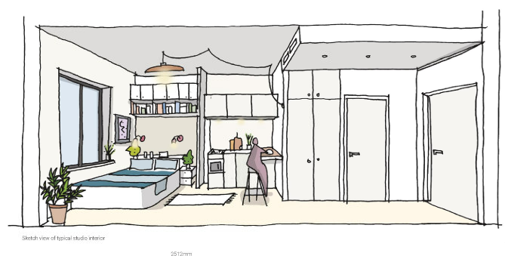

    - There are no windows proposed in the eastern flank wall. The proposed studios would have an outlook either to the north over the railway towards Harrow Town Centre, to the west or to the south facing towards the shopping parade on the southern side of Lowlands Road and over towards Harrow on The Hill. The proposed units would be single aspect, however 80% of windows have a southernly aspect. The application was accompanied by a Daylight and Sunlight Assessment which concluded that 94% (99 rooms) of all rooms achieve or surpass the Average Daylight Factor target. The BRE guide illustrates a good example of good layout design where only 20% of apartments have only north facing living room windows. With regards to the proposed development, 20% of studios would have only north facing living room windows and therefore the proposed development satisfies the BRE direct sunlight to window requirements.

    - In terms of stacking, the studios at first floor level would be sited above the ground floor co-working/café and communal areas. Four studios at 6th floor level would be sited beneath the seventh floor roof terrace. The 1st – 6th floors are based on a typical floor plan and therefore there would be no conflict between the studios on these floors. The proposed building is a purpose-built new building, which would need to comply with building regulations with regards to sound insulation measures to ensure there would be no unacceptable noise transmission. Therefore, the proposed development is acceptable in this regard.

    - Given the generally smaller size of the private studio spaces within co-living schemes, the communal amenity spaces are important elements to ensure the quality of the overall residential amenity is acceptable.

    - The proposed development includes the provision of the following:

Lower Ground 2 | Fitness room  Screening Room | 46 sqm  35 sqm
Lower Ground | Communal kitchen/diner  Laundry room  Courtyard | 109 sqm  23 sqm  25 sqm
Ground Floor | Co-working area and cafe | 91 sqm
Seventh Floor | Outdoor terrace  Library | 77 sqm  35 sqm
Eight Floor | Residents lounge  Outdoor terrace | 73 sqm  22 sqm

    - The type, location and amount of communal amenity spaces have been designed to create a sense of community, to lower barriers to social interaction and to facilitate engagement between residents. The amenity spaces are of a size and quality to encourage their use and community engagement and they are considered to be proportionate given the number of studios within the building.

    - The application sites does occupy a small urban site which is bounded by a railway and an A road, which is not uncommon in urban areas. The application was supported by an Acoustic Assessment. The Environmental Health Department was consulted and raised no objection to the proposal, subject to conditions.

    - Overall, it is considered that the internal design quality of the proposed development is of an acceptable standard and will ensure a good standard of living environment for future residents

Impact on Residential Amenity

    - Given that the railway bounds the northern boundary of the site, the proposed development would not result in a detrimental impact to the amenities of buildings located to the north, given their distance of approximately 52m and the intervening railway.

    - To the south of the application site is a parade of single storey shops and in addition, two-storey residential properties further along Lowlands Road. The proposed building is noted as maintaining a separation distance of 17m from the properties located towards the southwest, with an intervening public highway. Although the proposed building is higher than the existing building, it is noted that this relationship is representative of the commercial buildings located further to the east on Lowlands Road. Given the modest height of the proposed building in an urban setting, it is considered that this relationship is acceptable within an urban environment on the edge of a town centre.

    - Located to the east of the application property is No. 43-51 which is a 5 storey building, which has commercial on the ground floor and residential above. The proposed new build would be a further two storeys higher on this boundary than the existing building, adjacent to the party wall and stepping up a further two floors. The building line of the eastern corner of the building would respect that of the neighbouring building and as such the proposal would not interrupt a 45 degree splay taken from the front corner of the neighbouring property. Furthermore, no openings are proposed in the flank wall facing this building. As such would not unacceptably harm the amenities of the occupiers of these properties from a loss of light or daylight.

    - Overall, it is considered that given the size and scale of the proposed development and its relationship with neighbouring properties, it would not result in a detrimental impact to the residential and visual amenities of neighbouring properties.

    - The proposed development complies with the National Planning Policy Framework (2019), policy 7.6 of The London Plan (2016), policies H16, D1, D6 and D14 of The Draft London Plan (2019), policy CS1 of the Core Strategy (2012), policies DM1 and DM27 of the Harrow Development Management Policies Local Plan (2013).

  - Affordable Housing

    - The relevant policies are:

  - The London Plan (2016): 3.12, 3.13
  - The Draft London Plan (2019): H16
  - Harrow Core Strategy (2012): CS1
  - Harrow Development Management Polices Local Plan (2013):DM1, DM50

Relevant Supplementary Documents

  - Mayors Affordable Housing and Viability Supplementary Planning Guidance (2017)
  - Supplementary Planning Document: Planning Obligations and Affordable Housing (2013)

    - Policy 3.12 of the London Plan requires councils to seek the maximum reasonable amount of affordable housing when negotiating on individual private residential and mixed-use schemes. At the local level, overarching Policy CS1J of the Core Strategy (2012) sets a borough-wide affordable housing target of 40% of the housing numbers delivered from all sources of supply across the borough and calls for the maximum reasonable amount to be provided on development sites.

    - The Housing SPG confirms that new large scale shared living housing should contribute the maximum reasonable amount of affordable housing it can, in line with London Plan policies 3.12 and 3.13, but does not set out how that affordable housing contribution should be provided.

    - Policy H16 of the Draft London Plan (showing minor suggested changes) states that large-scale purpose-built shared living must deliver a cash in lieu contribution towards conventional C3 affordable housing. Boroughs should this this contribution for the provision of new C3 off-site affordable housing as either;

a) Upfront cash in lieu payment to the local authority; or
b) In perpetuity annual payment to the local authority

In both cases, developments are expected to provide a contribution that is equivalent to 35 percent of the units, to be provided at a discount of 50 percent of the market rent.

    - The applicant has submitted a Financial Viability Assessment to demonstrate how much affordable housing the scheme can deliver. The submitted information has been independently reviewed by an independent viability consultant and tested to ensure that assumptions and with regard to affordable housing is the maximum reasonable affordable housing that can be made as part of the proposed scheme. The independent review of the viability assessment has concluded that the assumptions are broadly accurate and that the scheme cannot support an affordable housing contribution.

    - The applicant has calculated the future value that any late stage review could capture, subject to market performance, based on the GLA’s late stage review formula. The methodology for the calculation of this offer was based on the viability inputs of the council’s independent viability consultant including their opinion on rental growth over the theoretical development plan applying build cost inflation. Based on this, it was calculated that a late stage review could capture £138,000 in affordable housing contributions. The applicant has increased this offer to £200,00 on the basis that the late stage review clauses are not applied in order tor reduce uncertainty and to assist the applicant in obtaining project financing. The Planning Policy Team Leader was consulted on this, and considers the methodology to be acceptable and is as per the methodology which was utilised for the determination of a previous co-living scheme – The Collective on Palmerston Road (P/2555/18). Taking into account that the applicant has proposed an offer which is likely to exceed any affordable housing contribution likely to be captured through a late stage review of a housing typology which is within an emerging market, it is considered to be acceptable. Furthermore, it is considered that the applicant’s financial contribution of £200,000 would assist the Council in delivering affordable housing within the borough and would assist in the delivery of mixed and balanced communities within the borough.

    - The Planning Obligations SPD (2013) seeks that for schemes that are below a policy compliant Affordable Housing offer, then a review mechanism ought to be applied. Whilst it is acknowledged that the proposed development is likely to be a single phased development, given the lifespan of the any permission (3 years), it is plausible that there could be a change in market circumstances prior to units being rented. Officers therefore consider that an early stage review mechanism should be employed to ensure that in the event that the commencement of the development is delayed, a viability reappraisal can be undertaken to capture any improvement in market conditions that will allow provision for affordable housing contributions to be sought as part of the development.

    - This approach is in line with Policy 3.12 of the London Plan. Officers also consider a late stage review would be appropriate so that the review can be based on values achieved and costs incurred and would accord with the guidance contained within the Mayor’s Affordable Housing SPG (2017).

    - Officers are satisfied that the review mechanisms are required to ensure that the maximum reasonable level of affordable housing contribution is secured. The details of the review mechanism will be secured through a planning obligation in the S106 agreement.

    - Subject to the above conditions, the proposed development complies with the National Planning Policy Framework (2019), policies 3.12 and 3.13 of The London Plan (2016), policy H16 of The Draft London Plan (2019), policy CS1 of the Core Strategy (2012), policies DM1 and DM50 of the Harrow Development Management Policies Local Plan (2013).

  - Traffic, Safety and Parking

    - The relevant policies are:

  - The London Plan (2016): 6.3, 6.9, 6.13
  - The Draft London Plan (2019): T4, T5, T6
  - Harrow Core Strategy (2012): CS1
  - Harrow Development Management Polices Local Plan (2013):DM1, DM42

    - This proposal is within a PTAL 6 and therefore access to public transport is excellent. There are bus stops, a rail and an underground station within a short walk and it is within walking distance to Harrow Town Centre.

    - Car and Cycle Parking

    - Policy T6.1 E of The Draft London Plan (2019) states - Large-scale purpose-built shared living, student accommodation and other sui generis residential uses should be car-free. In accordance with policy T6.1 E the proposed development does not include any standard parking spaces and it would be car-free, to be secured through a S106 Agreement. The Highways Officer has advised that for those who do occasionally need to travel by car, residents will be able to access existing car club vehicles which are located in the surrounding area (Roxborough Road, College Road and Gayton Road). In addition, the proposal includes three accessible spaces at ground floor level, to be accessed via Lowlands Road, in accordance with policy T6.1 of The Draft London Plan (2019).

    - The proposal includes a total of 124 cycle parking spaces: 104 spaces at lower ground 2 level and 20 spaces to the rear of the site at ground floor level. The Highways Officer confirmed that the proposed level of cycle parking and storage is acceptable, however a condition is appropriate to ensure details are submitted to the Local Planning Authority for approval prior to occupation.

Access and Servicing

    - The proposed development includes the closure of the existing accesses and to provide a new access towards the north of site, which is on a bend however, the Highways Officer confirmed that this position allows for good visibility in both directions. Whilst this new access will be closer to the point where the cycle track exits the subway and joins the carriageway it is considered that the parking area use will be low.

    - The proposed servicing arrangements have been determined based on the site being fairly constrained. Whilst on-street servicing is possible, a solution has been identified that would allow for some smaller vehicles to be able to use the under-croft facility. The Highways Officer confirmed that a formalised shared disabled/loading bay is not necessary as it would be possible to allow vans to use the area for loading/unloading if managed appropriately without designating a specific bay for this use. Taking some of the servicing activity off-highway would help to minimise the potential impact however this should not compromise dedicated disabled parking.

    - The applicant submitted an amended Transport Assessment to provide further details on the routes to key destinations along with any identified recommendations. The Highways Officer reviewed the amended Transport Assessment and confirmed that it is acceptable and no objections were raised, subject to conditions. It is therefore considered that the proposed development would be acceptable in Highway terms and would accord with policies 6.3, 6.9B and 6.13 of The London Plan (2016), policies T5, T6, T6.1 of The Draft London Plan (2019) and policies DM1 and DM42 of the Harrow Development Management Policies Local Plan (2013).

  - Development and Flood Risk

    - The relevant policies are:

  - The London Plan (2016): 5.12, 5.13
  - The Draft London Plan (2019): SI12, SI13
  - Harrow Core Strategy (2012): CS1
  - Harrow Development Management Polices Local Plan (2013): DM1, DM9, DM10

    - The application site is within surface water flood zone 3a and 3b. The application was accompanied by a Flood Risk Assessment . The Drainage Department was consulted who confirmed that the Flood Risk Assessment is satisfactory. The Drainage Engineer raised no objection to the proposed development subject to conditions to secure the submission of further detailed information.

    - Subject to the above, the proposal therefore complies with the National Planning Policy Framework (2019), policies 5.12 and 5.13 of The London Plan (2016), policy SI12 and SI13 of The Draft London Plan (2019), policy CS1 of the Core Strategy (2012) and policies DM1, DM9 and DM10 of the Harrow Development Management Policies Local Plan (2013).

  - Biodiversity

    - The relevant policies are:

  - The London Plan (2016): 7.19
  - The Draft London Plan (2019): G9
  - Harrow Core Strategy (2012):CS1
  - Harrow Development Management Polices Local Plan (2013):DM1, DM20, DM21

    - The application was accompanied by a Biodiversity Report. The Biodiversity Officer was consulted on the proposal and raised no objection to the proposed redevelopment subject to conditions relating to the submission of a Biodiversity Management Plan, and the provision of a green roof, bat roosts, bird boxes and invertebrate shelters.

    - Subject to the above conditions, the proposed development complies with the National Planning Policy Framework (2019), policy 7.19 of The London Plan (2016), policy G9 of The Draft London Plan (2019), policy CS1 of the Core Strategy (2012), policies DM1, DM20 and DM21 of the Harrow Development Management Policies Local Plan (2013).

  - Energy and Sustainability

    - The relevant policies are:

  - The London Plan (2016): 5.2, 5.3, 5.15
  - The Draft London Plan (2019): SI1, SI5
  - Harrow Core Strategy (2012): CS1
  - Harrow Development Management Polices Local Plan (2013): DM1, DM12, DM14

    - The application is accompanied by an Energy & Sustainability Statement which outlines a number of sustainability and carbon reduction proposals and is broadly considered to follow GLA guidance for such statements. In reducing carbon emissions, the energy statement follows the energy hierarchy by seeking to use less energy in the first instance (be lean), supplying energy efficiently (be clean) and finally using renewable energy (be green). By implementing the energy strategy as detailed in the Energy & Sustainability Statement, the carbon dioxide emissions for the development have been reduced by 40%. offset contribution will be required to fund carbon reduction measures elsewhere in the borough. This equates to a contribution of £52,740. Provided this contribution is secured through a section 106 contribution, the energy strategy is considered to meet relevant London Plan policies. In addition a condition requiring that the development is constructed and operated generally in accordance with the energy strategy submitted with the application has been added.

    - Subject to the above obligation and condition, the proposed development complies with the National Planning Policy Framework (2019), policies 5.2, 5.13 and 5.15 of The London Plan (2016), policy SI1 and SI5 of The Draft London Plan (2019), policy CS1 of the Core Strategy (2012), policies DM1, DM12 and DM14 of the Harrow Development Management Policies Local Plan (2013).

  - Accessibility

    - The relevant policies are:

  - The London Plan (2016): 3.5, 7.2
  - The Draft London Plan 2019: D5
  - Harrow Core Strategy 2012: CS1
  - Harrow Development Management Polices Local Plan (2013): DM1, DM2

    - The proposed scheme would provide 104 co-living units out of which 13 would be designed as wheelchair accessible. This would equate to approximately 13% which would accord with London Plan Policy. There would be inclusive access across the site and three disabled parking spaces would be provided.

    - Officers are satisfied that the proposals meet the development plan objectives in terms of accessibility and inclusive design and would contribute to the creation of a ‘lifetime neighbourhood’. On this basis, it is considered that the proposal complies with the high quality design aspirations of the National Planning Policy Framework (2019), policies 3.5 and 7.2 of The London Plan (2016), policy D5 of The Draft London Plan (2019), policy CS1 of the Core Strategy (2012), policies DM1 and DM2 of the Harrow Development Management Policies Local Plan (2013) and the Supplementary Planning Document: Residential Design Guide (2010).

- CONCLUSION AND REASONS FOR APPROVAL

  - The proposed development would deliver additional housing of a satisfactory layout and design to ensure that the future occupiers would benefit from a high standard of living accommodation. It is considered that the proposed building would have an acceptable design and external appearance and would not have an undue impact on the character and appearance of the area, the setting of the adjacent conservation area or area of special character or the residential amenity of neighbouring occupiers. Accordingly, the development would accord with development plan policies and is recommended for approval.

APPENDIX 1: Conditions and Informatives

Conditions

- Time Limit
The development hereby permitted shall be begun before the expiration of three years from the date of this permission.
REASON: To comply with the provisions of Section 91 of the Town and Country Planning Act 1990.

- Approved Drawing and Documents
Save where varied by other planning conditions comprising this planning permission or unless otherwise agreed in writing by the local planning authority, the development hereby permitted shall be carried out in accordance with the following approved plans to show the redevelopment of the site to provide a 9 storey building with basement level comprising of 104 co-living units (Use class Sui Generis) with communal living area; co-working space and cafe (Use Class A3) to ground floor level; proposed vehicle access; hard and soft landscaping; bin and cycle stores; parking

Approved Plans:
LRH-ASA-XX-00-DR-A-0001 R3; LRH-ASA-XX-00-DR-A-0002 R3; LRH-ASA-XX-00-DR-A-0003 R3; LRH-ASA-XX-00-DR-A-0004 R3; LRH-ASA-XX-00-DR-A-0005 R4; LRH-ASA-XX-00-DR-A-0006 R3; LRH-ASA-XX-00-DR-A-0007 R3; LRH-ASA-XX-00-DR-A-0010 R1; LRH-ASA-XX-00-DR-A-200 P13;
LRH-ASA-XX-00-DR-A-201 P13; LRH-ASA-XX-00-DR-A-202 P13; LRH-ASA-XX-00-DR-A-203 P13; LRH-ASA-XX-00-DR-A-204 P14; LRH-ASA-XX-00-DR-A-205 P13; LRH-ASA-XX-00-DR-A-206 P14; LRH-ASA-XX-00-DR-A-300 P4;
LRH-ASA-XX-00-DR-A-301 P4; LRH-ASA-XX-00-DR-A-400 P5; LRH-ASA-XX-00-DR-A-401 P5; LRH-ASA-XX-00-DR-A-402 P5; LRH-ASA-XX-00-DR-A-403 P5;

Approved Documents:
Car Park Management Plan; Basement Impact Assessment; Air Quality Assessment; Construction Logistics Plan (outline); Design and Access Statement; Daylight and Sunlight Study (Within Development);Delivery and Servicing Management Plan; Foul and Surface Water Drainage Strategy; Ecological Desk Study;Energy & Sustainability Statement; Flood Risk Assessment; Phase 1 Geoenvironmental Desk Study; Acoustic Assessment Report; Planning Statement; Statement of Community Involvement; Site Waste Management Plan; (Built) Heritage, Townscape and Visual Impact Assessment; Transport Assessment; Framework Travel Plan;
Arboricultural Survey and Impact Assessment; Co-Living Demand Study

REASON: For the avoidance of doubt and in the interests of proper planning.

- Construction Logistics Plan - PRECOMMENCEMENT CONDITION

No development shall take place, including any works of demolition, until a Detailed Construction Logistics Plan has been submitted to, and approved in writing by, the local planning authority in accordance with the format and guidance provided by the Transport for London – www.constructionlogisitcs.org. The Detailed Construction Logistics Plan shall provide for:
- Parking of vehicles of site operatives/visitors;
- HGV access to site – loading and unloading of plant and materials;
- Number of HGV’s anticipated;
- Storage of plant and materials used in constructing the development;
- Programme of work and phasing;
- Site layout plan;
- Highway condition (before, during, after);
- Measures to control dust, vibration and dirt during demolition, earthworks and construction;
- A scheme for recycling/disposing of waste resulting from demolition, earthworks and construction works;
- Details showing the frontage/ the boundary of the site enclosed by site hoarding to a minimum height of 2 metres;
- Details of cranes and other tall construction equipment (including obstacle lighting).
The development shall be carried out in accordance with the approved Detailed Construction Logistics Plan, or any amendment or variation to it as may be agreed in writing by the local planning authority.
REASON: To minimise the impacts of construction upon the amenities of neighbouring occupiers and to ensure that development does not adversely affect safety on the transport network.

Bird Hazard Management Plan - PRECOMMENCEMENT CONDITION

No development shall take place until a Bird Hazard Management Plan has been submitted to and approved in writing by the Local Planning Authority. In consultation with MOD, the Bird Hazard Management Plan shall includes design measures to minimise any increase in the numbers of hazardous species (primarily large or flocking birds) as a result of the development proposed, in particular provisions to prevent gulls from breeding (using appropriate licensed means) on site should be provided. The development shall be carried out strictly in accordance with the details set out in the approved Bird Hazard Management Plan in perpetuity or until RAF Northolt is no longer operational.
Reason: To minimise the potential of the works approved to provide a habitat desirable to hazardous large and/or flocking birds which have the potential to pose a considerable hazard to aviation safety which is exacerbated by the proximity of RAF Northolt.

Cranes - PRECOMMENCEMENT CONDITION

Development shall not commence until a construction management strategy has been submitted to and approved in writing by the local planning authority covering the application site and any adjoining land which will be used during the construction period. Such a strategy shall include the details of cranes and other tall construction equipment (including the details of obstacle lighting). The approved strategy (or any variation approved in writing by the Local Planning Authority) shall be implemented for the duration of the construction period.
REASON: To ensure that construction work and construction equipment on the site and adjoining land does not obstruct air traffic movements or otherwise impede the effective operation of air traffic navigation transmitter/receiver systems.

- Detailed Design and Method Statement – PRECOMMENCEMENT CONDITION

The development hereby permitted shall not be commenced until detailed design and method statements (in consultation with London Underground) for each stage of the development for demolition, all of the foundations, basement and ground floor structures, or for any other structures below ground level, including piling (temporary and permanent), have been submitted to and approved in writing by the local planning authority which:

- provide details on all structures- RAMS for all construction phases including demolition, excavation, foundation, basement and superstructure
- provide details on the use of tall plant/scaffolding including temporary works design and cat 3 check for scaffold
- accommodate the location of the existing London Underground structures - set back the new building by 3m from TfL Wall for the basement and ground floors
- there should be no opening windows or balconies facing the LU elevation
- demonstrate access to elevations of the building adjacent to the property boundary with London Underground can be undertaken without recourse to entering our land during construction and for future maintenance
- demonstrate that there will at no time be any potential security risk to our railway, property or structures
- accommodates ground movement arising from the construction to determine the impact and sub-sequential action such as monitoring or props depending on the results
- mitigate the effects of noise and vibration arising from the adjoining operations within the structures
- provides details of consultation and the prior approval for tree removal will be required as these works will most probably have to be completed during the Engineering Hours

REASON: To ensure that the development does not impact on existing London Underground transport infrastructure.

- Levels - PRECOMMENCEMENT CONDITION

No site works or development shall commence until details of the levels of the building(s), road(s) and footpath(s) in relation to the adjoining land and road/highway(s), and any other changes proposed in the level of the site, have been submitted to, and agreed in writing by the local planning authority. The development shall be carried out in accordance with the details so agreed.
REASON: To ensure that the works are carried out at suitable levels in relation to the highway and adjoining properties in the interests of the amenity of neighbouring residents, the appearance of the development, drainage, gradient of access and future highway improvement.

- Contamination - PRECOMMENCEMENT CONDITION

No demolition shall take place until a scheme for identifying, managing and disposing of any potential contamination hazards found during demolition of the existing buildings and structures on the site has first been submitted to, and agreed in writing by, the local planning authority. No development other than demolition shall take place until a scheme ('the second scheme') for the management of contamination risk at the site has first been submitted to, and agreed in writing by, the local planning authority. The second scheme shall include the following:
- details of a site investigation to provide information for a detailed assessment of the risks to all receptors that may be affected, including those off site;
- the results of the site investigation and an options appraisal and remediation strategy giving full details of remediation measures and how they are to be undertaken; and
- a verification plan providing details of the data that will be collected in order to demonstrate that the works set out in the remediation strategy are complete and identifying any requirements for longer-term monitoring of pollutant leakages, maintenance and arrangements for contingency action.

The demolition shall be carried out in accordance with the first scheme so agreed. The development other than demolition shall be carried out in accordance with the second scheme so agreed.
REASON: To ensure that the development does not activate or spread potential contamination at the site and that the land is appropriately remediated for the approved uses.

- Foul Disposal

The development other than demolition works hereby permitted shall not commence until details of the works for the disposal of sewage to be provided on site have been submitted to, and agreed in writing by, the Local Planning Authority. The development shall be carried out in accordance with the works so agreed and the works shall thereafter be retained.
REASON: To ensure that there is adequate waste water infrastructure in place to serve the development and to ensure the separation of surface and foul water systems.

- Surface Water Attenuation, Storage and Disposal

The development other than demolition works hereby permitted shall not commence until details for the works for the attenuation, storage and disposal of surface water to be provided on site have been submitted to, and agreed in writing by, the Local Planning Authority. The development shall be carried out in accordance with the works so agreed and the works shall thereafter be retained.
REASON: To ensure that the development incorporates sustainable drainage systems and achieves greenfield run-off rates, and to ensure the separation of surface and foul water systems.

Fire Strategy

The development hereby approved shall not progress beyond damp proof course level until a Fire Statement produced by a third party suitably qualified assessor has been submitted to, and agreed in writing by, the local planning authority. The development shall be carried out in accordance with the strategy so agreed and shall be retained as such thereafter unless otherwise agreed by the local planning authority or Fire Authority.
REASON: To ensure that the development proposals achieve the highest standard of fire safety.

Basement Protection

Notwithstanding the approved plans, the development other than demolition works, hereby permitted shall not commence until details for basement protection for ground water flooding, which would include waterproofing and water tanking details, have been submitted and approved by the Local Planning Authority. The development shall be completed in accordance with the approved details and shall thereafter be retained.

REASON: To build in resistance and resilience in managing, reducing and mitigating the effects of flood risk.

Permeable Paving

The development other than demolition works hereby permitted shall not commence until full details of the permeable paving and details relating to the long term maintenance and management of the on-site drainage are submitted to and approved in writing by the Local Planning Authority. Details thereby approved shall be retained thereafter.
REASON: To ensure that the development has adequate drainage facilities, to reduce and mitigate the effects of flood risk and would not impact the character and appearance of the development.

Noise and Vibration

The development other than demolition works hereby permitted shall not commence until a scheme which specifies the provision to be made for the control of noise (including noise from people emanating from the site) and vibration from the hereby approved cinema and café on the flats above and the neighbouring properties, has been submitted to and approved in writing by the Local Planning Authority. The scheme shall include such combination of physical, administrative measures, noise and vibration limits and other measures as may be approved by the Local Planning Authority. Thereafter, the scheme shall be installed and shall be operational prior to the first occupation of the flats, or the commencement of the use of the cinema, whichever is the soonest, and shall be maintained in full compliance with the approved details and shall be thereafter retained, unless otherwise agreed in writing by the Local Planning Authority.
REASON: In order to safeguard the amenities of neighbouring residents.

Materials

Notwithstanding the details shown on the approved drawings, the development shall not progress beyond damp proof course level until samples of the materials (or appropriate specification) to be used in the construction of the external surfaces noted below have been submitted to the Local Planning Authority to be agreed in writing,:
- facing materials for the buildings, including roof;
- windows including reveals;
- doors;
- balconies and terraces including privacy screens;
- decking;
- louvers;
- boundary treatment including all pedestrian/ access gates;
- Rainwater disposal systems (including downpipes) and soil stacks;
- ground surfacing.
The development shall be carried out in accordance with the details so agreed and shall be retained as such thereafter.
REASON: To ensure that the development is carried out to the highest standards of architecture and materials.

External Lighting

Notwithstanding the approved details, the development hereby permitted shall not progress beyond damp proof course level, until details of the lighting of all public realm and other external areas (including buildings) within the site has been submitted to the Local Planning Authority. This includes all details of the lighting including sourcing/ manufacturer details, location, height type, direction of light sources, specification, elevations, light spillage and lighting levels The development shall be implemented in accordance with the approved details and shall be retained as such thereafter.

REASON: To ensure that the development incorporates lighting that contributes to Secured by Design principles, achieves a high standard of quality.

Water Consumption

The development hereby approved shall not progress beyond damp proof course level until a strategy for the efficient use of mains water within the residential parts of the development, pursuant to a water consumption limit of 105 litres per person per day, has been submitted to, and agreed in writing by, the Local Planning Authority. The development shall be carried out in accordance with the strategy so agreed and shall be retained as such thereafter.

REASON: To ensure that the development makes efficient use of mains water.

Boundary Treatment

Notwithstanding the approved details, the development hereby permitted shall not progress beyond damp proof course level, until a plan indicating the positions, design, materials and type of boundary treatment/screening to be erected has been submitted to, and approved in writing by, the local planning authority. The development shall be completed in accordance with the approved details prior to occupation, and shall thereafter be retained.

REASON: To safeguard the amenity of neighbouring residents and the character of the locality.

Soft and Hard Landscaping

Notwithstanding the approved details, the development hereby permitted shall not progress beyond basement level, until details of soft and hard landscaping for the site has been submitted to, and approved in writing by the Local Planning Authority which shall include:

a) A scheme for detailed hard and soft landscaping of the development, to include details of the planting, hard surfacing materials, raised planters and external seating and so on. Soft landscaping works shall include: planting plans (at a scale not less than 1:100), written specification of planting and cultivation works to be undertaken and schedules of plants, noting species, plant sizes, plant container sizes (all at time of planting) and proposed numbers / densities and an implementation programme. The hard surfacing details shall include samples to show the texture and colour of the materials to be used and information about their sourcing/manufacturer.

b) Green roofs, hard and soft landscape details and planting plans, the roofs terraces and courtyard and roof (if incorporated) at the lower ground, seventh and eighth floor and the roof area, including written specification of the planting, planting plans, details of the proposed irrigation or any watering system to be installed for regular watering in dry / drought conditions for the landscaped areas maintenance and proposed ongoing plant replacement, for any plant failures, during the lifetime of the built development;

c) Full scale metric cross sections and elevations for all communal open amenity spaces (at a scale of not less than 1:100).

d) Details of all furniture, boundary treatment, specification for supports and fixings for plants, landscape structures and any climbing plant frames, including proposed material and source / manufacturer, irrigation for planting and detailed drawings of such; for all communal areas, raised beds, furniture and bespoke furniture.
The development shall be implemented in accordance with the scheme so agreed and shall be retained as such thereafter.
REASON: To ensure that the development makes provision for hard and soft landscaping which contributes to the creation of a high quality, accessible, safe and attractive public realm and to ensure a high standard of design, layout and amenity.

Landscape Management Plan

Notwithstanding the approved details, the development hereby permitted shall not progress beyond basement level, until a Landscape Management Plan and Landscape Maintenance Plan for the site has been submitted to, and approved in writing by the Local Planning Authority to ensure the future success of the development, which shall include long term design objectives, management responsibilities and maintenance schedules, including the lower ground level hard and soft landscape, outdoor terraces, green roofs and any biodiverse roofs and landscape structures for plant growth and a programme of maintenance including a calendar of routine physical tasks for all landscape areas / plant replacement for the life time of the development for landscape structures. The Landscape Maintenance Plan shall cover a 5 year period for the whole of the proposed development to ensure the future success of the development including all the hard and soft landscape.
The development shall be implemented in accordance with the scheme so agreed and shall be retained as such thereafter.
REASON: To ensure that the development makes provision for hard and soft landscaping which contributes to the creation of a high quality, accessible, safe and attractive public realm and to ensure a high standard of design, layout and amenity.

Inclusive Access Strategy

The development hereby approved shall not progress beyond first floor level until an inclusive access strategy for the site has been submitted to, and agreed in writing by, the Local Planning Authority. The strategy shall:
- demonstrate inclusive access within the proposed development including the cinema and cafe unit;
- detail the arrangements for disabled residents' access to the disabled parking spaces and the access, and use of, waste and recycling facilities within the development.
The development shall be carried out in accordance with the approved details prior to the commencement of the use of the café or disabled parking spaces, whichever is the soonest and shall be retained as such thereafter.
Reason: To ensure that the development contributes to the achievement of a lifetime neighbourhood.

Biodiversity Management Plan

The development other than demolition works hereby permitted shall not commence until detailed proposals for ongoing management, monitoring and reporting of onsite biodiversity features, including details of how this will be funded in perpetuity have been submitted to and approved in writing by the Local Planning Authority. The Biodiversity Management Plan shall include:
- how these features will be managed and monitored to maintain and enhance their value, including any replacements during the establishment phase (to run for three years from the commencement of construction);
- year by year schedule of the timing of operations and who has responsibility for these and for ensuring they are undertaken;
- how the plan will be updated at 5 year intervals; and
- how these operations will be funded over the lifetime of the new development, during and following construction.

The development shall be carried out in accordance with the proposals so agreed and shall be retained as such thereafter.
Reason: To ensure that the development makes appropriate provision for the protection, enhancement, creation and management of biodiversity within the site and surrounding area.

Air Extraction System

No air extraction system shall be used on the premises until a scheme for the control of noise and odour emanating from the site has been submitted to and approved in writing by the Local Planning Authority. The scheme shall include such combination of measures as may be approved by the LPA. Thereafter, the air extraction system shall be implemented and maintained in full compliance with the approved details and shall be thereafter retained, unless otherwise agreed in writing by the Local Planning Authority.
REASON: In order to safeguard the amenities of neighbouring resident.

Travel Plan

The development hereby permitted shall not be first occupied until there has been first submitted to, and approved in writing by, the local planning authority a revised Travel Plan to include TRICS data to assess existing data from the locality, targets to promote model shift towards active travel. Details should include cycle trips associated with the development and details of how/where residents and visitors can obtain cycle training. The travel plan shall be implemented as agreed unless otherwise agreed in writing by the local planning authority.
REASON: To promote sustainable modes of travel for the future occupies of the development.

Landscape Management and Maintenance Plan

The development hereby approved shall not be first occupied until a Landscape Management and Maintenance Plan has been submitted to and approved in writing by the Local Planning Authority, for all landscaped areas and any landscape structure for plant growth, other than privately owned domestic balconies/terraces. The Landscape Management and Maintenance Plan shall include:

- Landscape Management: long term design objectives incorporating the overall functional aesthetic objectives of the landscape scheme; management responsibilities; programme of works and monitoring procedures; and
- Landscape Maintenance: including routine physical tasks required to satisfy appropriate standards of aftercare and enable the design and implementation objectives to be achieved, for the first year of maintenance, years 2-5 and 6 years onwards: maintenance responsibilities; a schedule of maintenance operations (calendar of tasks)set out graphically and in writing.
The Landscape Management and Maintenance Plan shall be carried out in accordance with the approved details.
REASON: To ensure the future success of the development and to enhance the appearance of the development.

Communal Aerials

Prior to the first occupation of the residential units hereby permitted, details of a strategy for the provision of communal facilities for television reception (eg. aerials, dishes and other such equipment) shall be submitted to and approved in writing by the Local Planning Authority. Such details shall include the specific size and location of all equipment. The approved details shall be implemented prior to the first occupation of the residential units and shall be retained thereafter. No other television reception equipment shall be installed on the building without the prior written approval of the Local Planning Authority.
REASON: To ensure that any telecommunications apparatus and other plant or equipment that is required on the exterior of the buildings preserves the high quality design of the buildings and spaces.

Secured by Design
Prior to the first occupation of the development, evidence of Secured by Design Certification shall be submitted to the Local Planning Authority in writing to be agreed, or justification shall be submitted where the accreditation requirements cannot be met. Secure by design measures shall be implemented where practical and the development shall be retained in accordance with the approved details.

REASON: In the interests of creating safer and more sustainable communities and to safeguard amenity by reducing the risk of crime and the fear of crime

Parking Design and Management Plan

The development hereby approved shall not be first occupied until a detailed parking design and management plan is submitted to and approved in writing by the Local Planning Authority to set out how parking will be allocated / controlled. The parking management plan shall set out details of disabled parking provision; active and passive electric vehicle charging points in accordance with London Plan standards. The arrangements so agreed shall be put in place prior to the first occupation of the units hereby approved and shall thereafter be retained.
To ensure appropriate parking provision in accordance with the National Planning Policy Framework (2019), Policy 6.13 of the London Plan (2016) and Policy DM 42 of the Harrow Development Management Policies Local Plan (2013).
REASON: To ensure car parking provision is available for use by the occupants and visitors of the site.

- Car Parking

The residential units hereby permitted shall not be occupied until three accessible parking spaces of a standard size have been clearly marked out on site, in accordance with the approved ground floor plan. Such spaces shall not be used for any purposes other than for the parking of motor vehicles used by residents of the development for blue badge holders/disabled persons only, and for no other purpose, unless otherwise agreed in writing by the Local Planning Authority.
REASON: To ensure car parking provision is available for use by the occupants of the site.

Residential Cycle Parking

The residential units hereby permitted shall not be occupied until details for secured, sheltered and accessible storage for the provision of 124 cycle spaces have been submitted and approved in writing by the Local Planning Authority. Such cycle storage should be designed in accordance with the requirements of the London Cycle Design Standards. The development shall be completed in accordance with the approved details prior to the occupation of the residential units, and shall thereafter be retained.
REASON: To ensure that cycle storage is available for use by the occupants of the site.

Bat Roosting/Hibernation Shelters

Prior to first occupation of the development hereby approved, details of the following shall be submitted to and approve in writing by the Local Planning Authority:
- 9 Schwegler 2FTR interconnecting bat tubes (or equivalent), placed in three groups of three, at heights of 3 and 5 storeys above ground level on the south aspect of the new building, away or otherwise sheltered from direct night time illumination.
The bat roosts shall be installed in accordance with the approved details, and shall be retained as such thereafter.
REASON: To ensure that the development makes appropriate provision for the protection, enhancement, creation and management of biodiversity.

Bird Boxes

Prior to first occupation of the development hereby approved, details of the following shall be submitted to and approved in writing by the Local Planning Authority:
- 5 double or treble cavity swift nest boxes (e.g. Schwegler 17B)
- 3 house sparrow terraces (e.g. Schwegler 1SP)
- 3 nesting cavities for starlings (e.g. Schwegler Brick Box Type 24 with the entrance cover removed/enlarged)
- 1 kestrel nestbox (e.g. Schwegler Built-in Multi-system cavity with kestrel front panel)

The bird boxes shall be embedded within the fabric of the building, in locations that take account of each species preferences, on north or east building aspects. The bird boxes shall be installed in accordance with the approved details, and shall be retained as such thereafter.
REASON: To ensure that the development makes appropriate provision for the protection, enhancement, creation and management of biodiversity.

Invertebrate shelters

Prior to first occupation of the development hereby approved, details of the following shall be submitted to and approve in writing by the Local Planning Authority:
- 2+ cedar ‘slab shelters to be constructed and fitted to the exterior on the south and east aspects, as follows: Sheets of (c. 2+ cm thick and c. W. 20+ x L. 30+ cm) untreated cedar board screwed to exterior wall on S aspect, with two 0.5-0.8 cm (by 2.5 x 2.5) ‘lugs’ at glued to the bottom on the wall side (to provide a slight offset from the wall which will narrow toward the top. These will provide shelter for a range of other invertebrates.

The invertebrate shelters shall be installed in accordance with the approved details, and shall be retained as such thereafter.
REASON: To ensure that the development makes appropriate provision for the protection, enhancement, creation and management of biodiversity.

Refuse Stores – Residential

The refuse store and refuse collection area as shown on the approved ground floor plan shall be provided prior to the first occupation of the flats and shall be thereafter retained.
REASON: To ensure satisfactory refuse stores are provided, which are accessible to refuse collectors.

Refuse Bin Storage

The refuse bins shall be stored at all times, other than on collection days, in the designated refuse collection area, as shown on the approved drawing plans.
REASON: To safeguard the appearance and character of the surrounding area, in accordance with policy 7.4.B of The London Plan (2016) and ensure a high standard of residential quality.

Permitted Development Restrictions – Communications

Notwithstanding the provisions of Part 16 (Communications) to Schedule 2 of the Town and Country Planning (General Permitted Development) Order 2015, or any order revoking and replacing that Order with or without modification, no development that would otherwise be permitted by that part of the Order (or the equivalent provisions of any replacement Order) shall be carried out without planning permission having first been obtained by the Local Planning Authority.
REASON: To ensure that the architectural integrity of the building is not compromised.

Audio Visual Control

The development hereby approved shall not be occupied until: (i) an audio-visual access control system has been installed; or (ii) such alternative security measures have been installed that shall first have been submitted to, and agreed in writing by, the Local Planning Authority. The development shall be completed in accordance with the approved details and shall thereafter be retained in that form.
REASON: To ensure that the development achieves a high standard of residential quality for future occupiers of the development.

Noise and Vibration – Certification

Within three months following the completion of the installation of the noise and vibration mitigation measures (as per the approved details subject to condition 14 of this permission), the applicant shall submit written evidence to the Local Planning Authority to confirm that the works have been carried out and completed in accordance with the approved details, as per condition 10 of this permission.
REASON: In order to safeguard the amenities of neighbouring residents in accordance with policy 7.15 of The London Plan (2016) and policy DM1 of the Harrow Development Management Policies Local Plan (2013).

Hours of Operation

The opening hours of the café shall be between:
- 09:00 hrs to 23:00 Sundays to Thursdays (inclusive) and public holidays and;
- 09:00hrs to 24:00 hrs on Fridays and Saturdays.
REASON: In order to safeguard the amenities of the residents.

Deliveries

There shall be no deliveries and the loading or unloading of goods outside the hours of 0800 and 2000, Monday to Friday, and between the hours of 0900 and 1300 on Saturdays. There shall be no deliveries on Sundays or Bank Holidays.
REASON: To safeguard the amenities of neighbouring properties within the locality.

Landscape Implementation

All planting, seeding or turfing comprised in the approved details of landscaping shall be carried out in the first planting and seeding seasons following the occupation of the building(s), or the completion of the development, whichever is the sooner. Any existing or new trees or shrubs which, within a period of 5 years from the completion of the development, die, are removed, or become seriously damaged or diseased, shall be replaced in the next planting season, with others of a similar size and species, unless the Local Planning Authority agrees any variation in writing.
REASON: To safeguard the appearance and character of the area, and to enhance the appearance of the development.

INFORMATIVES

Relevant Policies

The following policies are relevant to this decision:

National Planning Policy Framework (2019)
The London Plan (2016):
2.15, 3.3, 3.4, 3.5C, 3.6, 6.7, 3.8, 3.9, 3.11, 3.12, 3.13, 4.12, 5.2, 5.3, 5.10, 5.11, 5.13, 5.14, 5.15, 5.21, 6.3, 6.9, 6.13, 7.1, 7.2, 7.3B, 7.4B, 7.5, 7.6B, 7.7, 7.8, 7.13, 7.14, 7.15, 7.19, 7.21
The Draft London Plan (2019):
D1, D2, D3, D4, D5, D6, D7, D8, D9, D11, D12, D13, H1, H2, H5, H8, H12, H16, HC1, G5, G6, G7, SI1, SI2, SI3, SI5, SI8, SI13, T2, T3, T4, T5, T6, SD6, SD7
Harrow Core Strategy (2012):
CS1
Harrow and Wealdstone Area Action Plan (2013)
AAP1, AAP4, AA6, AAP8, AAP13, AAP19, AAP20
Harrow Development Management Policies Local Plan (2013):
DM1, DM2, DM3, DM6, DM7, DM9, DM10, DM12, DM13, DM14, DM15, DM20, DM21, DM22, DM23, DM27, DM28, DM31, DM32, DM35, DM40, DM41, DM42, DM43, DM44, DM45, DM50
Supplementary Planning Documents:
Supplementary Planning Document: Residential Design Guide (2010)
Supplementary Planning Document: Planning Obligations and Affordable Housing (2013)
Supplementary Planning Document : Accessible Homes (2010)
Technical Housing Standard (2015) Code of Practice for Storage and Collection of Refuse and Materials for Recycling in Domestic Properties (2008).
Mayors Housing Supplementary Planning Guidance (2016)
Roxborough Park and the Grove Conservation Area Appraisal and Management Strategy (2008)

Pre-application engagement

Statement under Article 35(2) of The Town and Country Planning (Development Management Procedures) (England) Order 2015
This decision has been taken in accordance with paragraphs 187-189 of The National Planning Policy Framework. Pre-application advice was sought and provided and the submitted application was in accordance with that advice.

Mayoral CIL

Please be advised that approval of this application (either by Harrow Council, or subsequently by the Planning Inspectorate if allowed on appeal following a refusal by Harrow Council) will attract a Community Infrastructure Levy (CIL) liability, which is payable upon the commencement of development. This charge is levied under s.206 of the Planning Act 2008 Harrow Council, as CIL collecting authority, has responsibility for the collection of the Mayoral CIL The Provisional Mayoral CIL liability for the application, based on the Mayoral CIL levy rate for Harrow of £60/sqm is £216,540

The floorspace subject to CIL may also change as a result of more detailed measuring and taking into account any in-use floor space and relief grants (i.e. for example, social housing).

You are advised to visit the planningportal website where you can download the appropriate document templates.
Please complete and return the Assumption of Liability Form 1 and CIL Additional Information Form 0 .
https://ecab.planningportal.co.uk/uploads/1app/forms/form_1_assumption_of_liability.pdf
https://ecab.planningportal.co.uk/uploads/1app/forms/cil_questions.pdf
If you have a Commencement Date please also complete CIL Form 6:
https://ecab.planningportal.co.uk/uploads/1app/forms/form_6_commencement_notice.pdf
The above forms should be emailed to HarrowCIL@Harrow.gov.uk
Please note that the above forms must be completed and provided to the Council prior to the commencement of the development; failure to do this may result in surcharges and penalties

Considerate Contractor Code of Practice

The applicant's attention is drawn to the requirements in the attached Considerate Contractor Code of Practice, in the interests of minimising any adverse effects arising from building operations, and in particular the limitations on hours of working.

Party Wall Act

The Party Wall etc. Act 1996 requires a building owner to notify and obtain formal agreement from adjoining owner(s) where the building owner intends to carry out building work which involves:
1. work on an existing wall shared with another property;
2. building on the boundary with a neighbouring property;
3. excavating near a neighbouring building,
and that work falls within the scope of the Act.
Procedures under this Act are quite separate from the need for planning permission or building regulations approval.
“The Party Wall etc. Act 1996: Explanatory booklet” is available free of charge from:
Communities and Local Government Publications, PO Box 236, Wetherby, LS23 7NB
Please quote Product code: 02 BR 00862 when ordering
Also available for download from the CLG website:
http://www.communities.gov.uk/documents/planningandbuilding/pdf/
133214.pdf
Tel: 0870 1226 236 Fax: 0870 1226 237
Textphone: 0870 1207 405
E-mail: communities@twoten.com

Compliance with Planning Conditions

IMPORTANT: Compliance With Planning Conditions Requiring Submission and Approval of Details Before Development Commences - You will be in breach of planning permission if you start development without complying with a condition requiring you to do something before you start. For example, that a scheme or details of the development must first be approved by the Local Planning Authority. Carrying out works in breach of such a condition will not satisfy the requirement to commence the development within the time permitted.- Beginning development in breach of a planning condition will invalidate your planning permission.
- If you require confirmation as to whether the works you have carried out are acceptable, then you should apply to the Local Planning Authority for a certificate of lawfulness.

Liability For Damage to Highway

The applicant is advised to ensure that the highway is not interfered with or obstructed at any time during the execution of any works on land adjacent to a highway. The applicant is liable for any damage caused to any footway, footpath, grass verge, vehicle crossing, carriageway or highway asset. Please report any damage to nrswa@harrow.gov.uk or telephone 020 8424 1884 where assistance with the repair of the damage is available, at the applicants expense. Failure to report any damage could result in a charge being levied against the property.

Street Numbering

Harrow Council is responsible for the naming and numbering of new or existing streets and buildings within the borough boundaries. The council carries out these functions under the London Government Act 1963 and the London Building Acts (Amendment) Act 1939.
All new developments, sub division of existing properties or changes to street names or numbers will require an application for official Street Naming and Numbering (SNN). If you do not have your development officially named/numbered, then then it will not be officially registered and new owners etc. will have difficulty registering with utility companies etc.
You can apply for SNN by contacting technicalservices@harrow.gov.uk or on the following link.
http://www.harrow.gov.uk/info/100011/transport_and_streets/1579/street_naming_and_numbering

Thames Water Assets

The proposed development is located within 15m of Thames Water underground assets and as such the development could cause the assets to fail if appropriate measures are not taken. Please read our guide ‘working near our assets’ to ensure your workings are in line with the necessary structures https://developers/Devoloping-a-large-site/Planning-your-development/Working-near-or-diverting-our-pipes. Should you require further information please contact Thames Water. Email: developer.services@thameswater.co.uk Phone: 0800 009 3921 (Monday to Friday, 8am to 5pm) Write to: Thames Water Developer Services, Clearwater Court, Vastern Road, Reading, Berkshire RG1 8DB

Ground Water

A Groundwater Risk Management Permit from Thames Water will be required for discharging groundwater into a public sewer. Any discharge made without a permit is deemed illegal and may result in prosecution under the provisions of the Water Industry Act 1991. It is expected for the developer to demonstrate what measures will be undertaken to minimise ground water discharges not the public sewer. Permit enquiries should be directed to Thames Water’s Risk Management Team by telephoning 02035779483 or by emailing wwqriskmanagement@thameswater.co.uk.

Surface Water Drainage

Thames Water would advise that if the developer follows a sequential approach to the disposal of water. Prior approval will be required for the discharge to a public sewer. For further information please visit Thames Water website.

Sustainable Drainage Systems

The applicant is advised that surface water run-off should be controlled as near to its source as possible through a sustainable drainage approach to surface water management (SUDS). SUDS are an approach to managing surface water run-off which seeks to mimic natural drainage systems and retain water on or near the site as opposed to traditional drainage approaches which involve piping water off site as quickly as possible.

SUDS involve a range of techniques including soakaways, infiltration trenches, permeable pavements, grassed swales, ponds and wetlands. SUDS offer significant advantages over conventional piped drainage systems in reducing flood risk by attenuating the rate and quantity of surface water run-off from a site, promoting groundwater recharge, and improving water quality and amenity.
Where the intention is to use soak ways they should be shown to work through an appropriate assessment carried out under Building Research Establishment
(BRE) Digest 365.
Support for the SUDS approach to managing surface water run-off is set out in the National Planning Policy Framework (NPPF) and its accompanying technical guidance, as well as the London Plan. Specifically, the NPPF (2012) gives priority to the use of sustainable drainage systems in the management of residual flood risk and the technical guidance confirms that the use of such systems is a policy aim in all flood zones. Policy 5.13 of the London Plan (2016) requires development to utilise sustainable drainage systems unless there are practical reasons for not doing so. Sustainable drainage systems cover the whole range of sustainable approaches to surface drainage management. They are designed to control surface water run-off close to where it falls and mimic natural drainage as closely as possible. Therefore, almost any development should be able to include a sustainable drainage scheme based on these principles.
The applicant can contact Harrow Drainage Section for further information.

Designing Out Crime

For further information regarding Secure By Design, the applicant can contact the North West London Designing Out Crime Group on the following: DOCOMailbox.NW@met.police.uk

London Underground Infrastructure

The applicant is advised to contact London Underground Infrastructure Protection in advance of preparation of final design and associated method statements, in particular with regard to: demolition; drainage; excavation; construction methods; tall plant: scaffolding: security; boundary treatment; safety barriers; landscaping and lighting

Network Management

The developer is urged to make early contact with Network Management in order to agree any temporary traffic management measures required; these should then be included in the detailed CLP for submission.

Interim Chief Planning Officer | Orla Murphy pp Beverley Kuchar 11.9.20
Corporate Director | Paul Walker 11.9.20

APPENDIX 2: SITE PLAN

APPENDIX 3: SITE PHOTOS

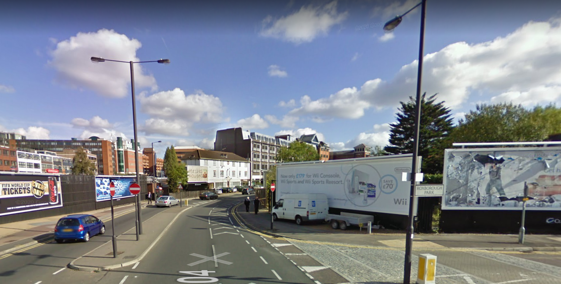

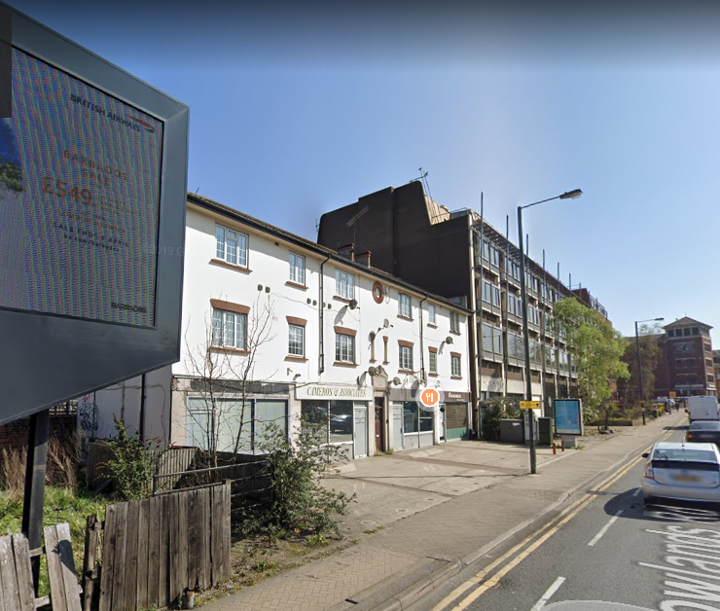

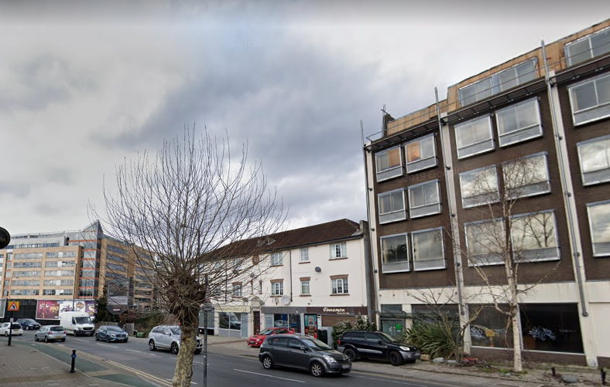
APPENDIX 4: PLANS AND ELEVATIONS

Existing Site Plan

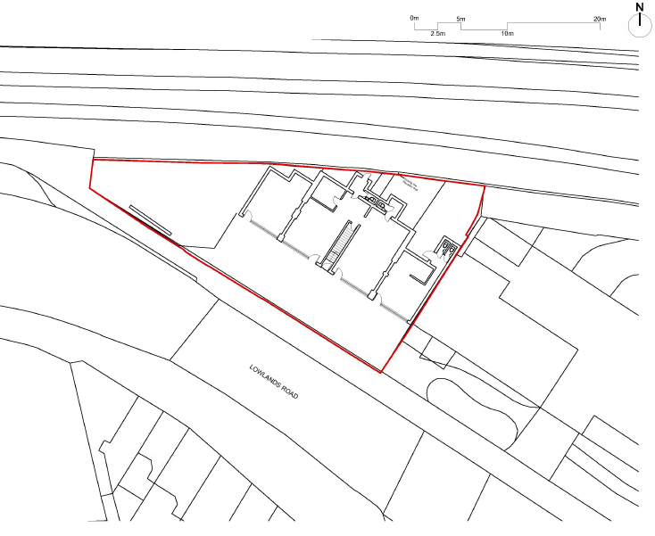

Existing Front and Rear Elevations

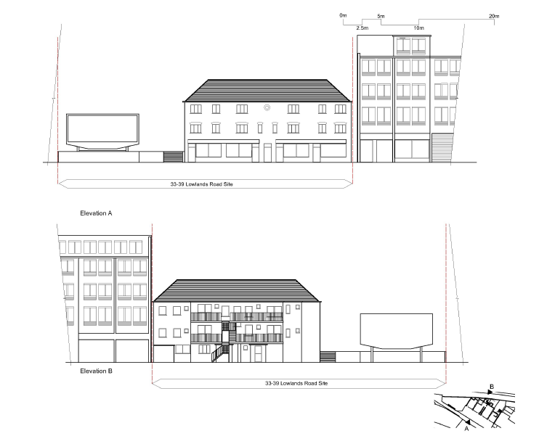

Proposed 3D Visual (Front)

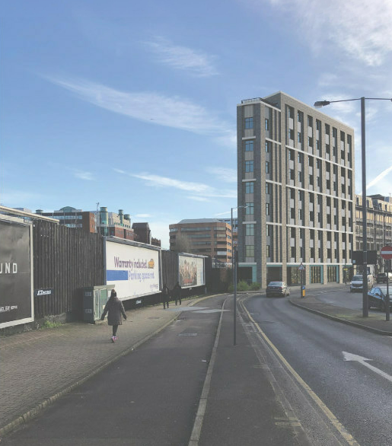

Proposed Site Plan /Ground Floor Plan

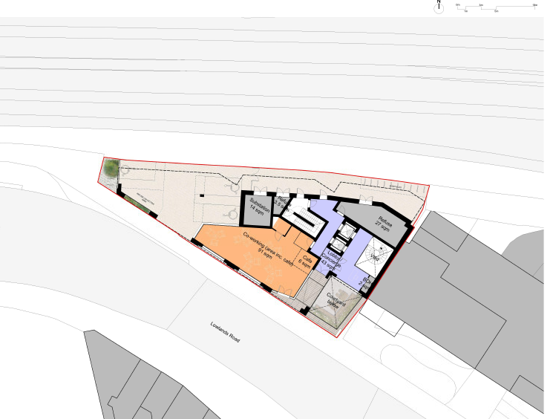

Proposed First – Sixth Floor

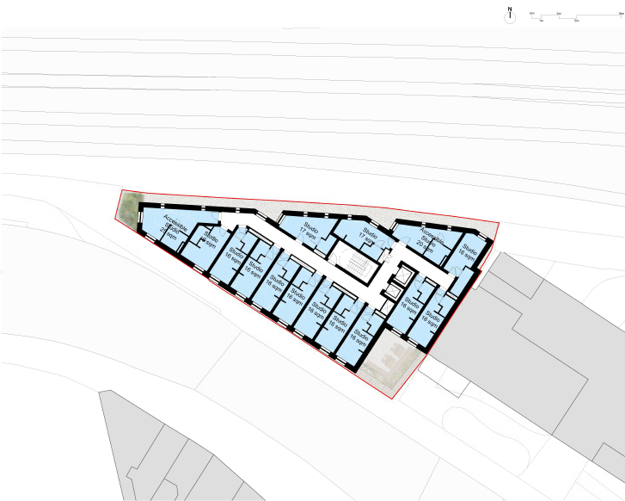

Proposed Seventh Floor

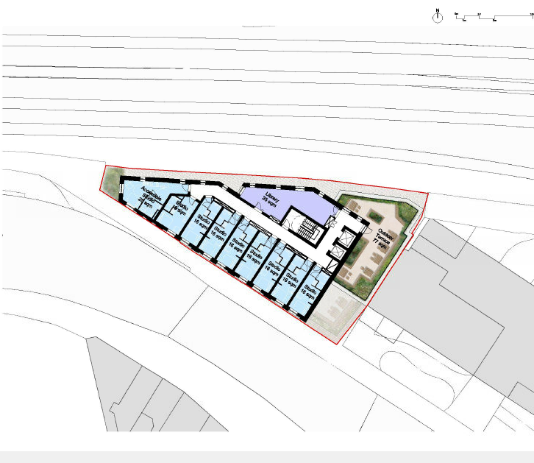

Proposed Eigth Floor

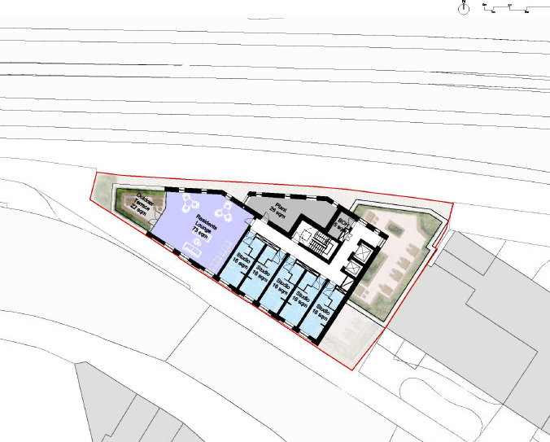

Proposed South (Front) Elevation

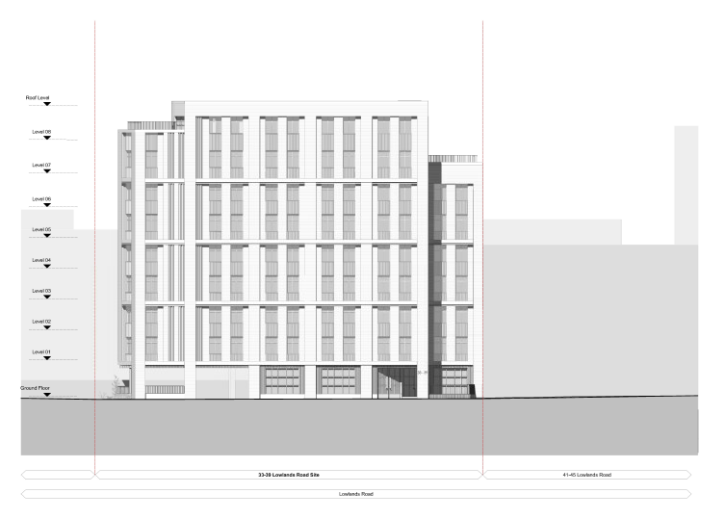

Proposed North (Rear) Elevation

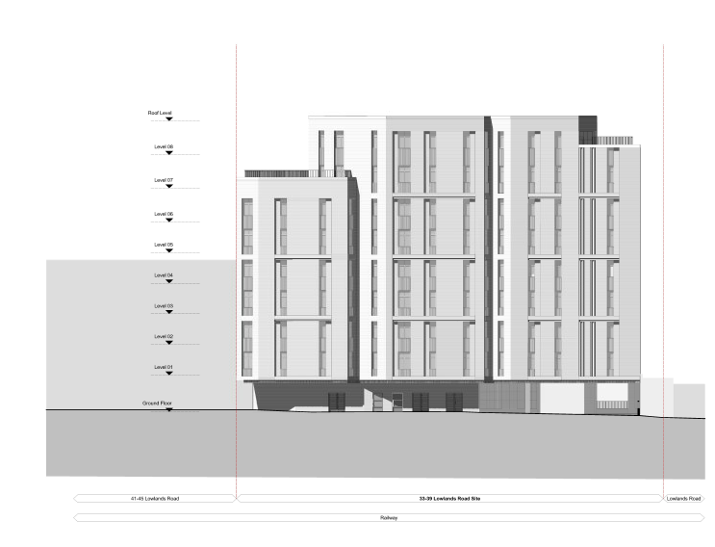

Proposed Section

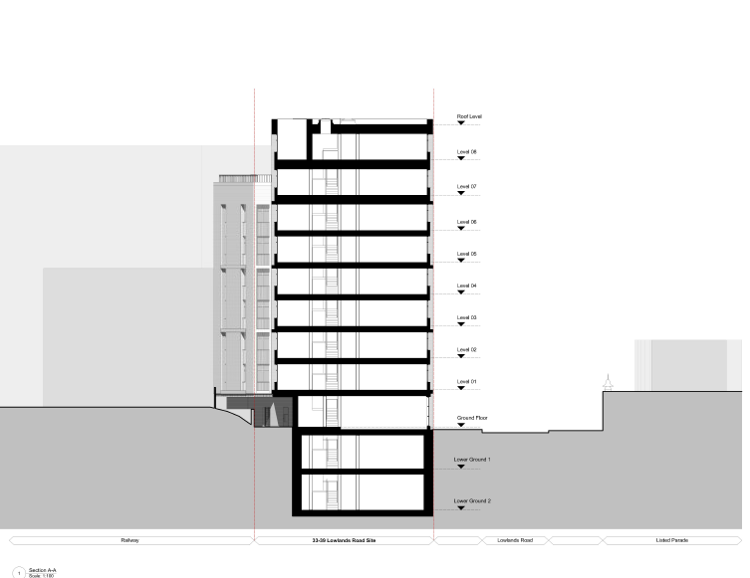

Proposed West Elevation
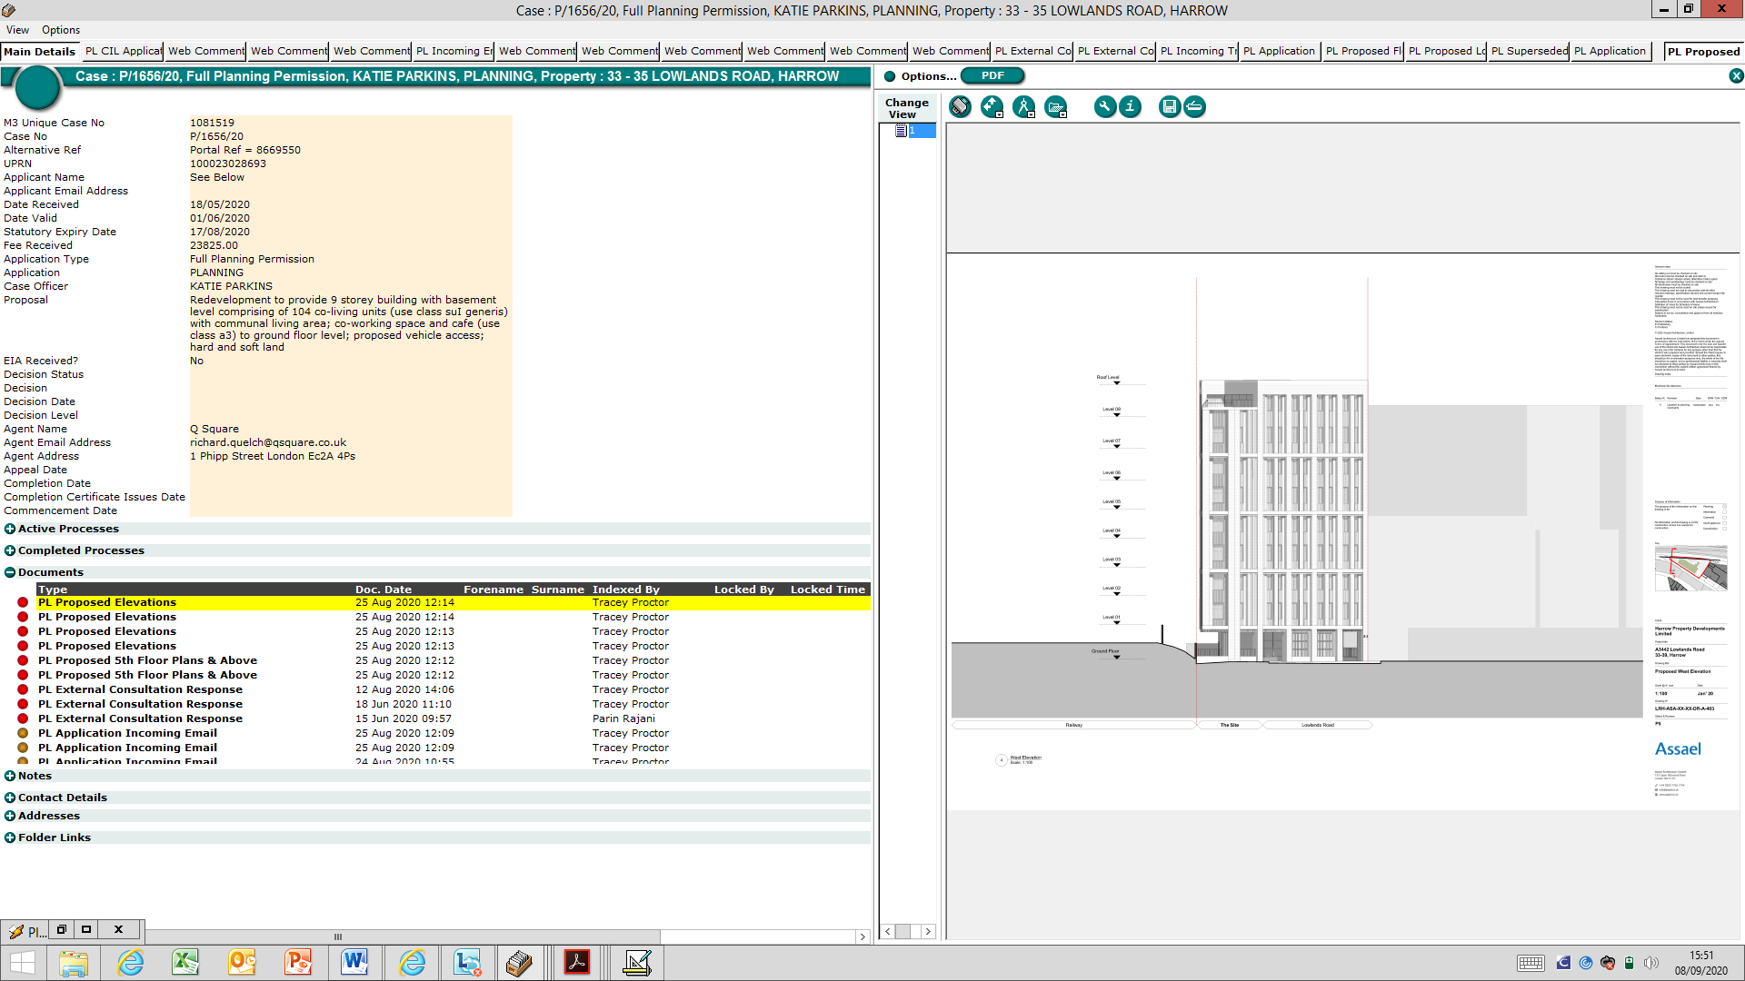

Proposed East Elevation

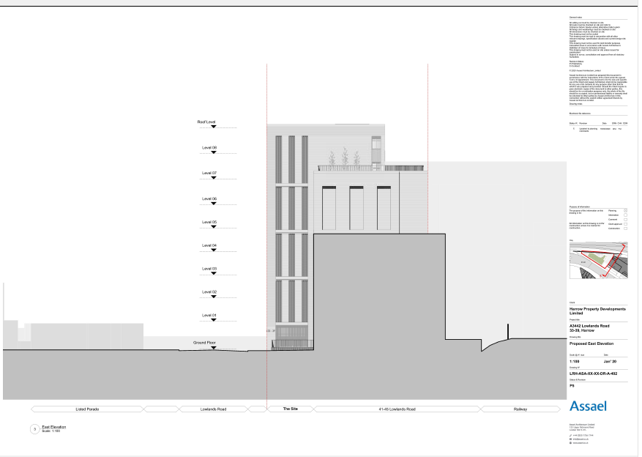

This page has been left intentionally blank

